

**Sri Lanka Institute of Information Technology**

**IE2012: System and Network Programming**

**Year 2 Semester 1**

**Assignment**

**IT23209534**

**A.A.I.Nethmika**

Table of Content

1. Basic Linux Environments 3

1.1) Virtual Machine Setup 3

1.2) Basic Navigation Commands and functionalities. 16

1.3) File manipulation commands 17

1.4) System Information Commands 18

1.5) User management commands. 19

2. DHCP, DNS and NTP Services 20

2.1) DHCP (Dynamic Host Configuration Protocol) 20

2.2) Installation and configuration 20

2.3) DNS (Domain Name System) 26

2.4) Installation and Configuration 26

2.5) NTP (Network Time Protocol) 32

2.6) Installation and Configuration 32

3. Shell Scripting and Security 35

3.1) Shell Scripting 35

3.2) SSH (Secure Shell) 46

3.3) Iptables and ACLs 49

4. Best Practices 53

# **Basic Linux Environments**

## Virtual Machine Setup

Download Oracle VirtualBox using <https://www.virtualbox.org/wiki/Downloads>.

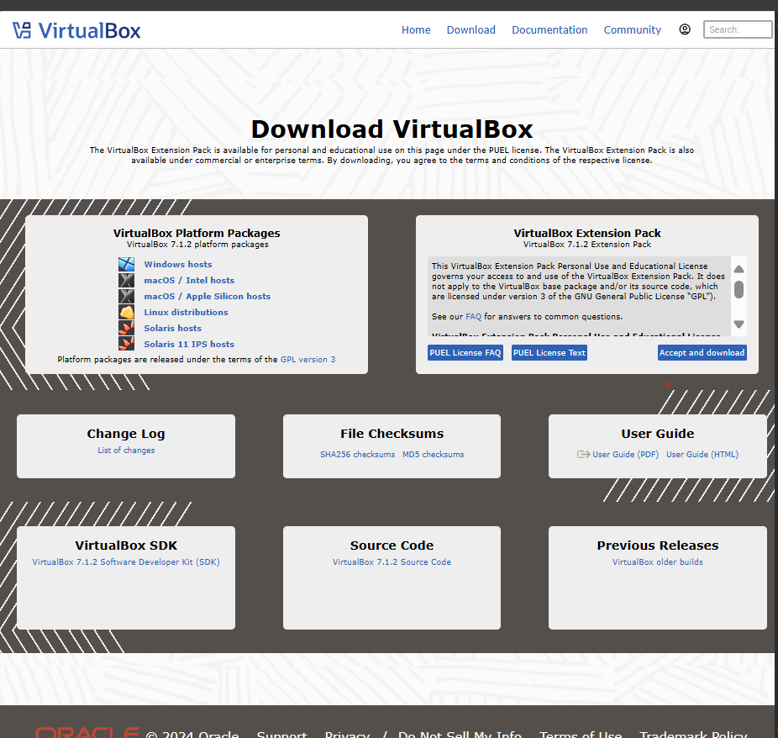

After downloading the windows host Oracle VirtualBox, Run the setup.

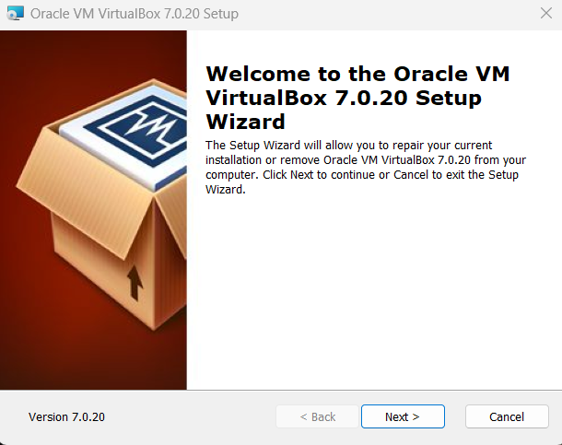

Select the preferred setting and install the VirtualBox. (VirtualBox software has already been installed in my computer)

Download Ubuntu from <https://ubuntu.com/download/desktop>.

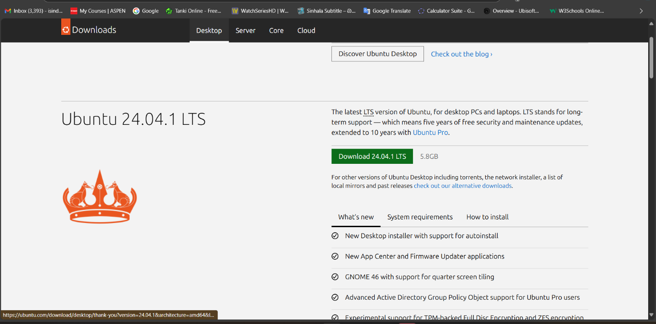

Run VirtualBox. Use new button to add new virtual machine.

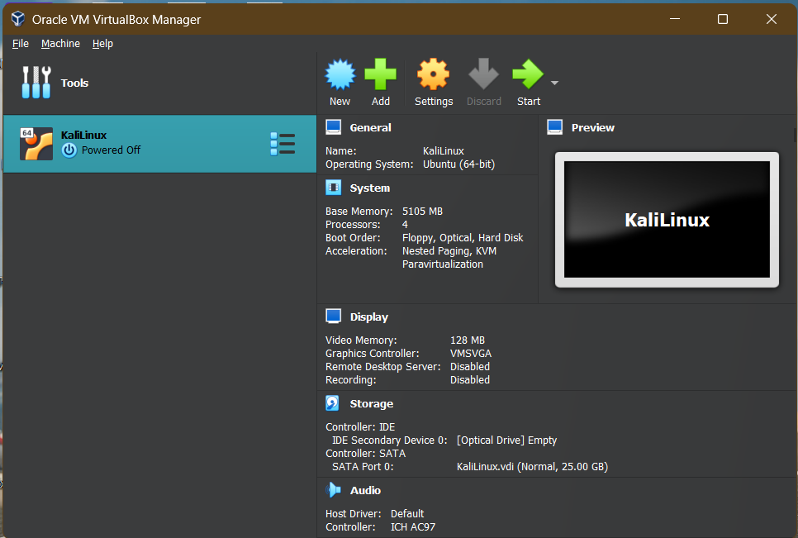

Enter a name and select the Iso file (Downloaded ubuntu ISO file) and press Next.

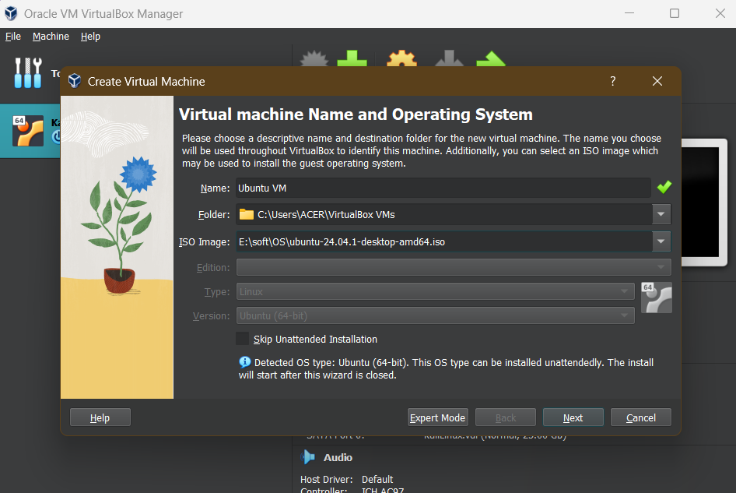

Then Enter a username and password

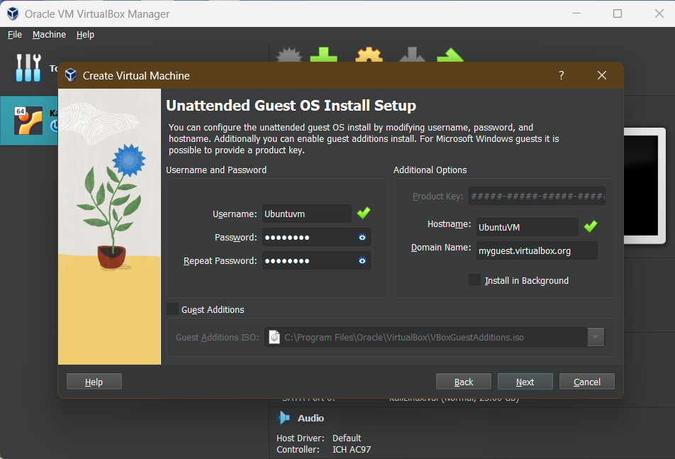

Select enough Base Memory space and Processors.

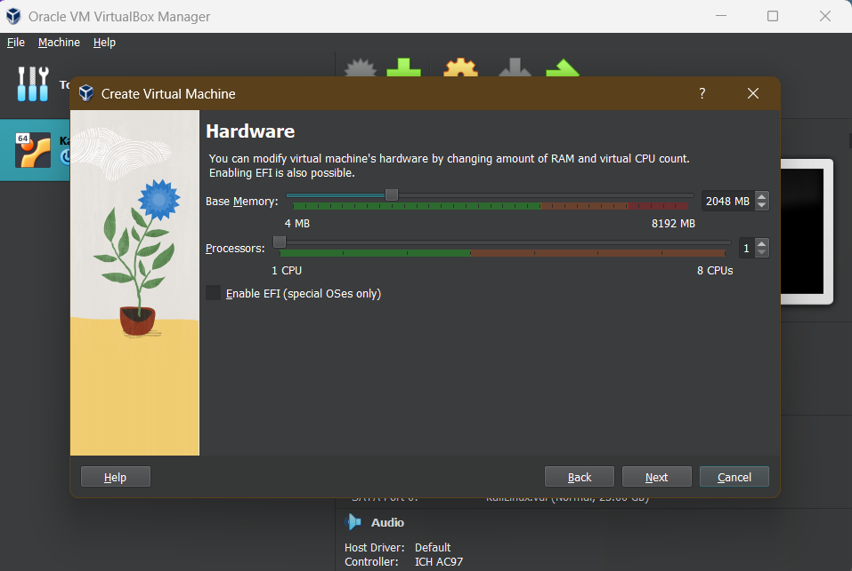

Select enough disk space for the virtual machine.

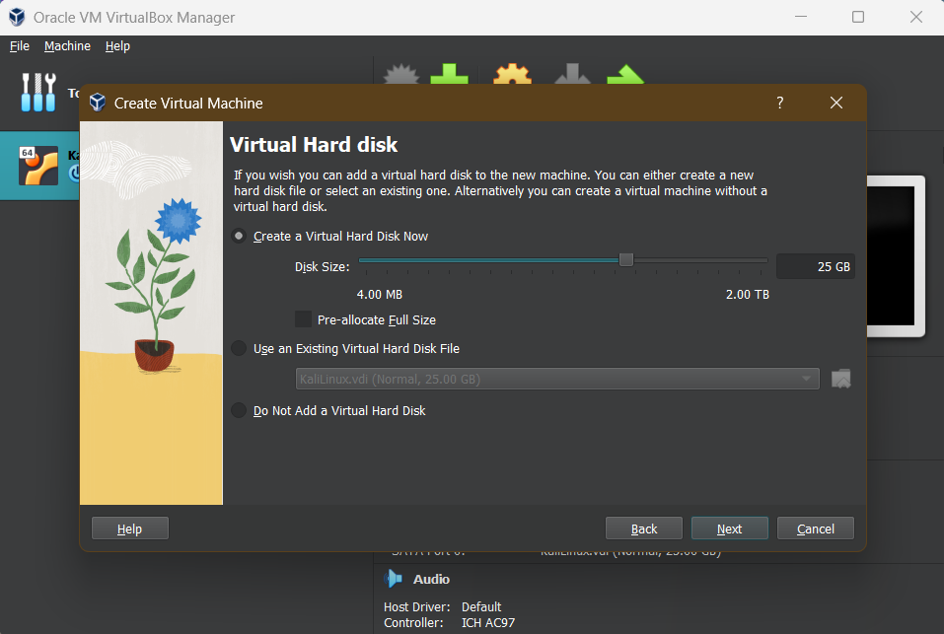

Check and confirm the settings. If everything is correct press finish.

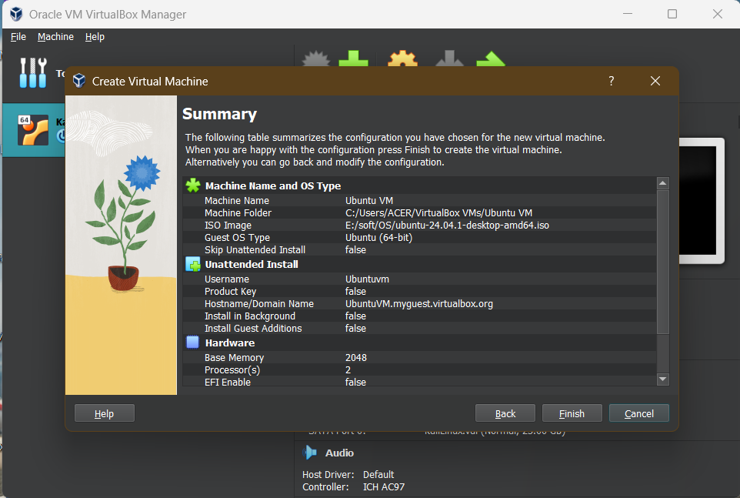

Now select the newly created virtual machine and click on start.

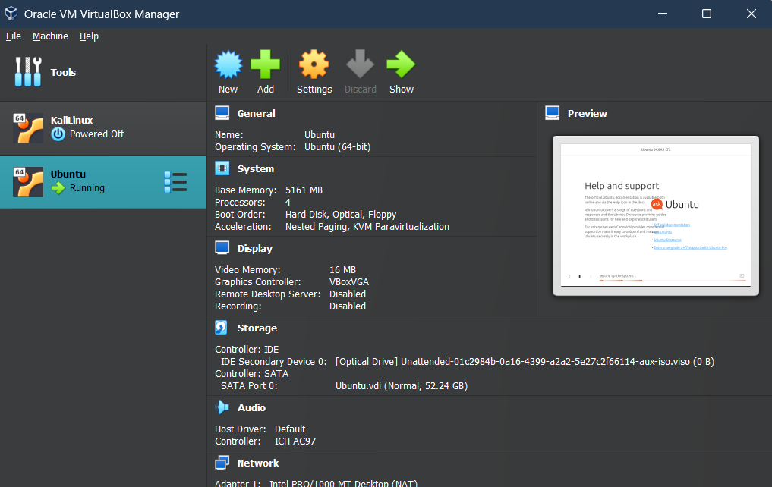

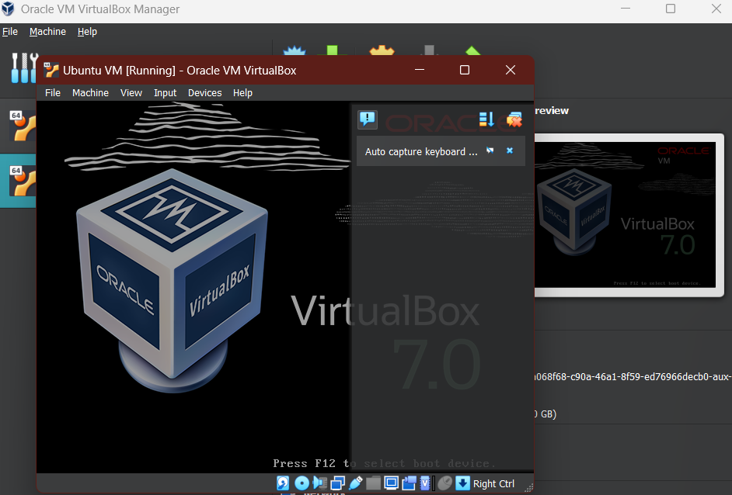

Select Try or install Ubuntu options (Highlighted option will be selected automatically after certain period.

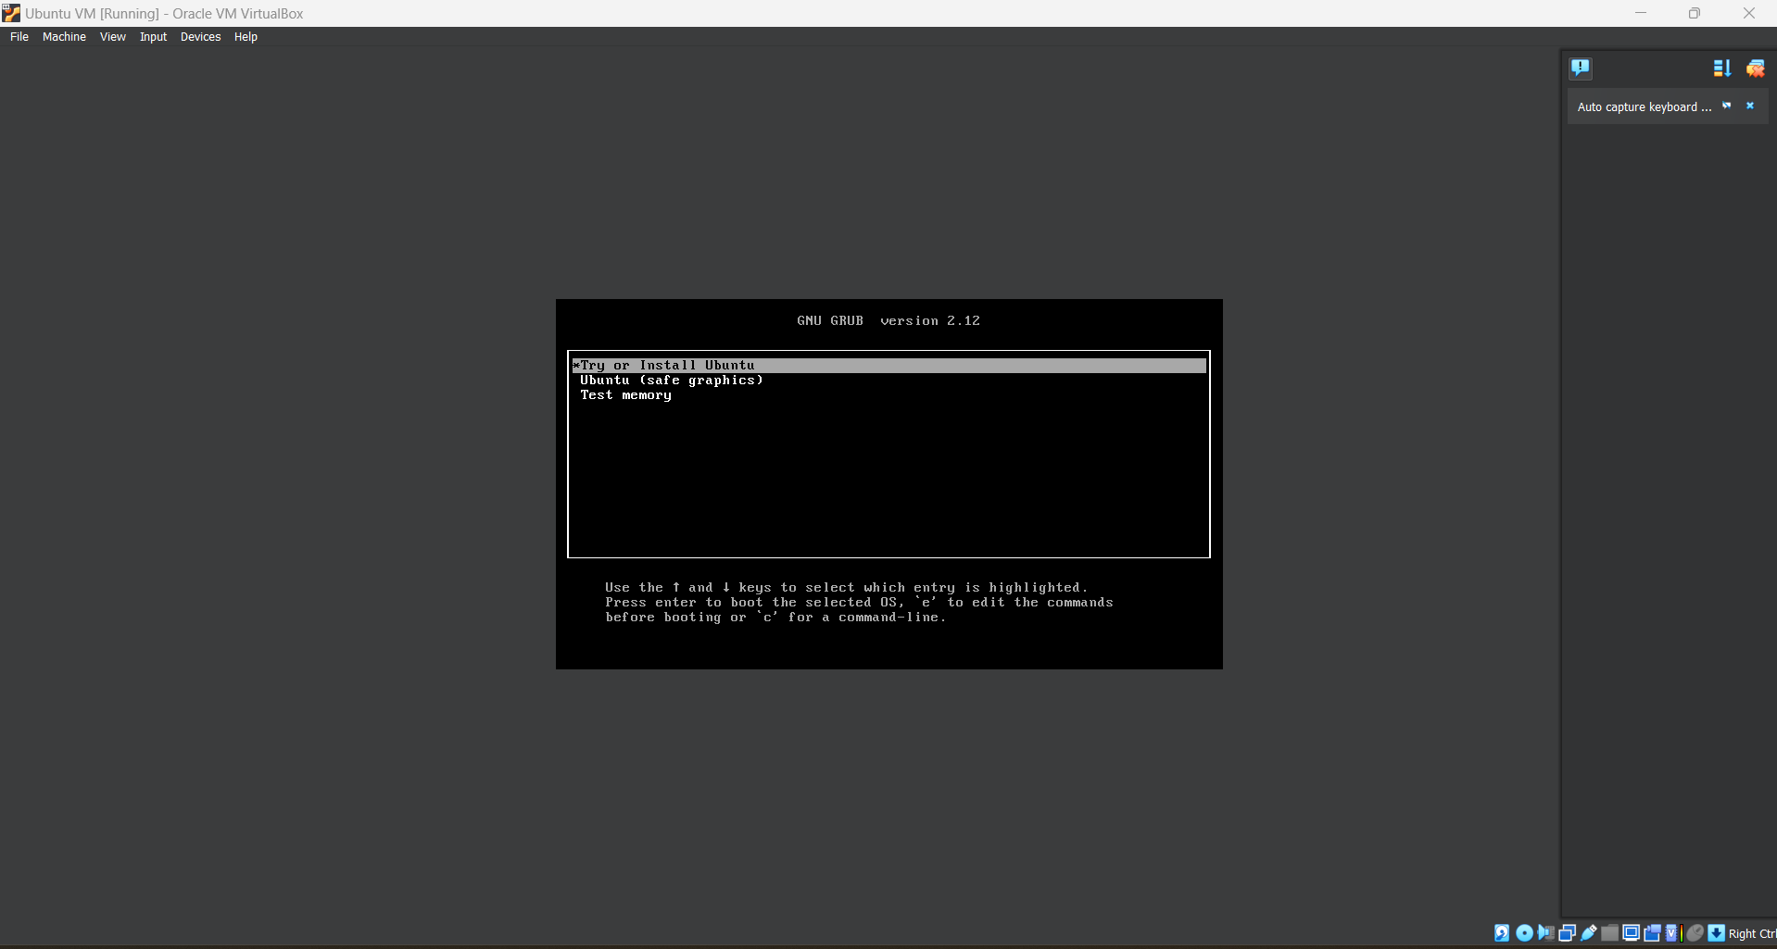

Then Select preferred settings and install Ubuntu.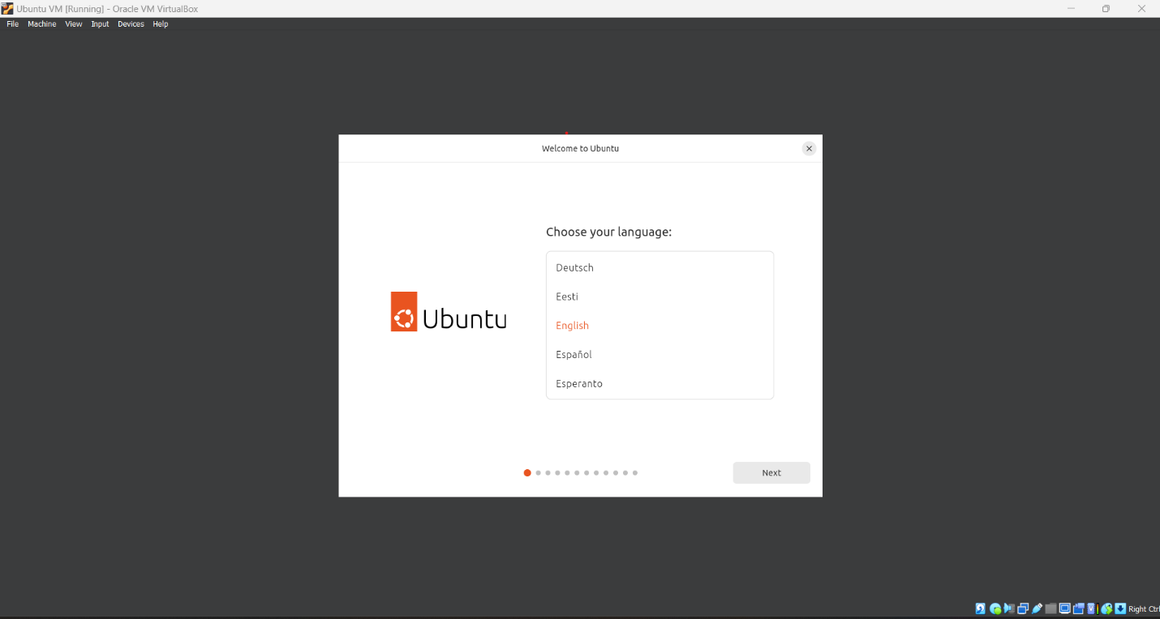

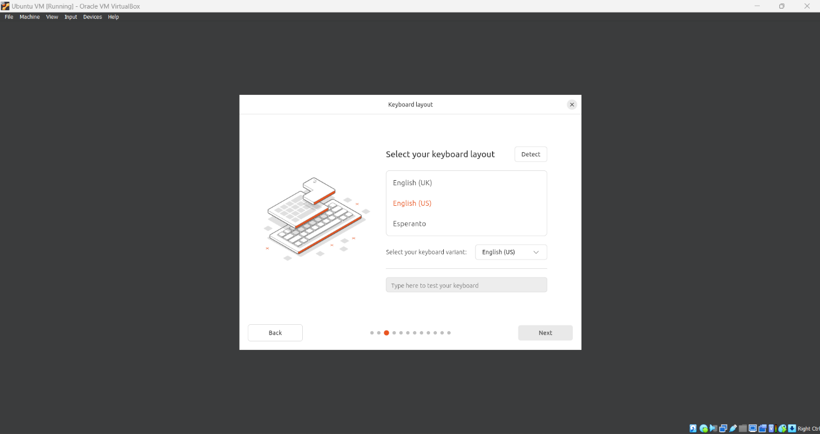

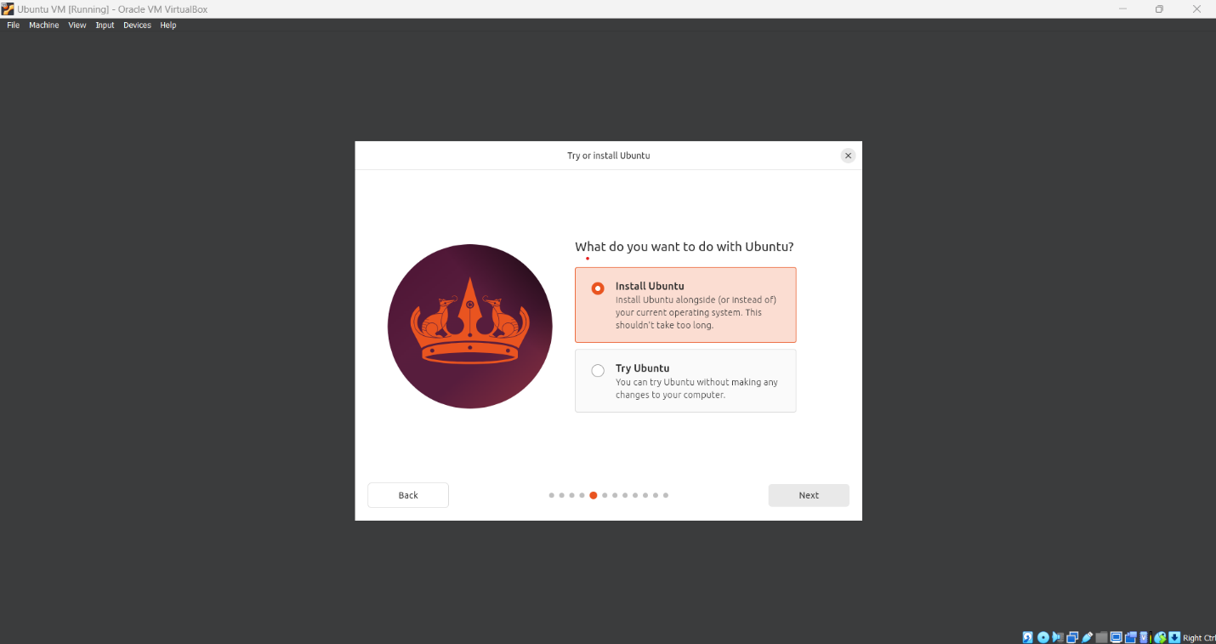

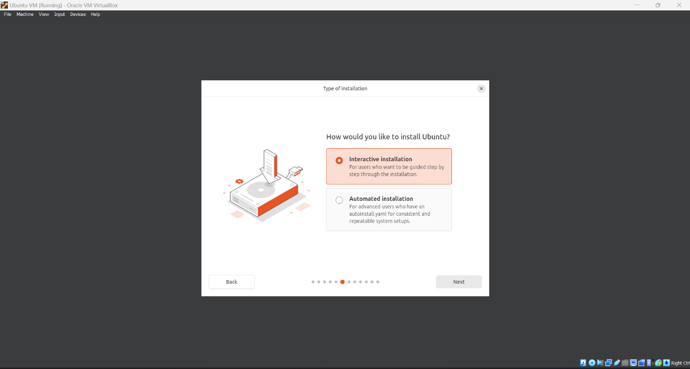

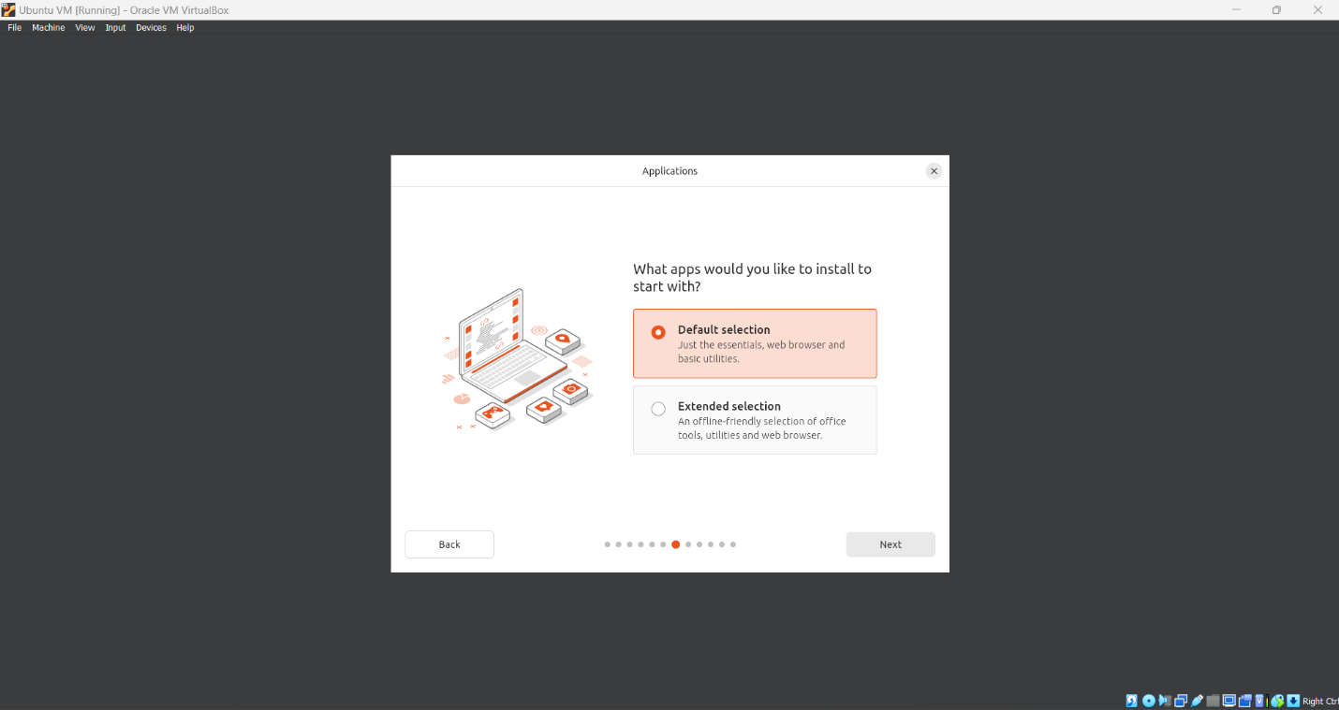

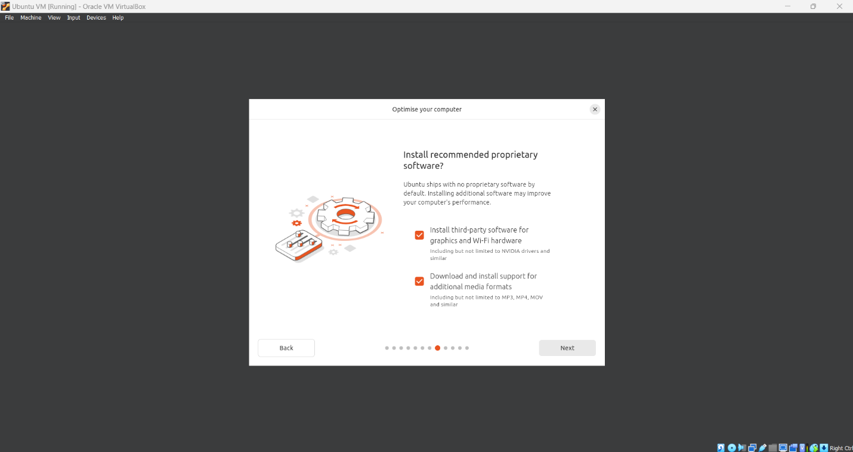

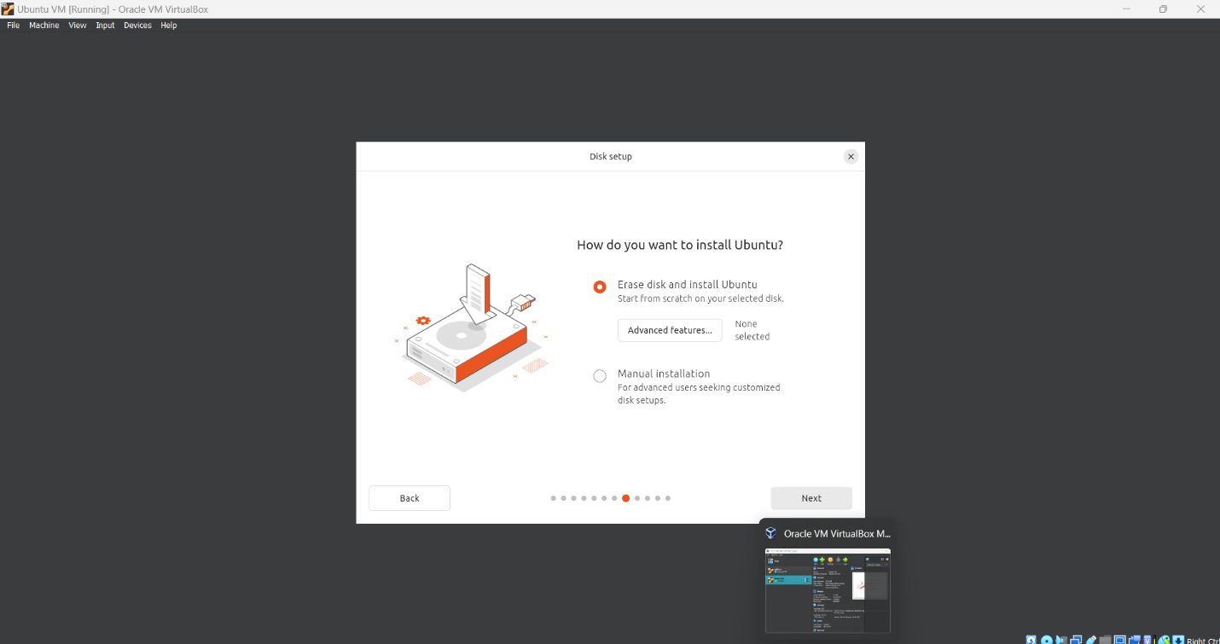

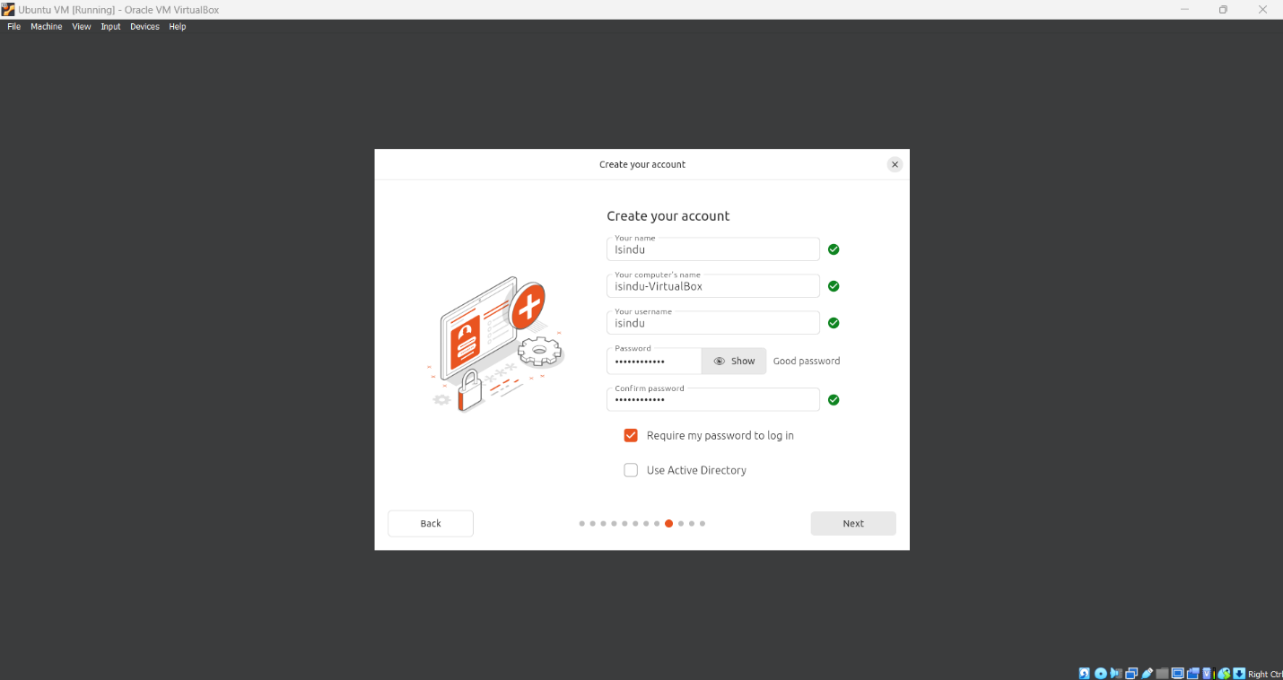

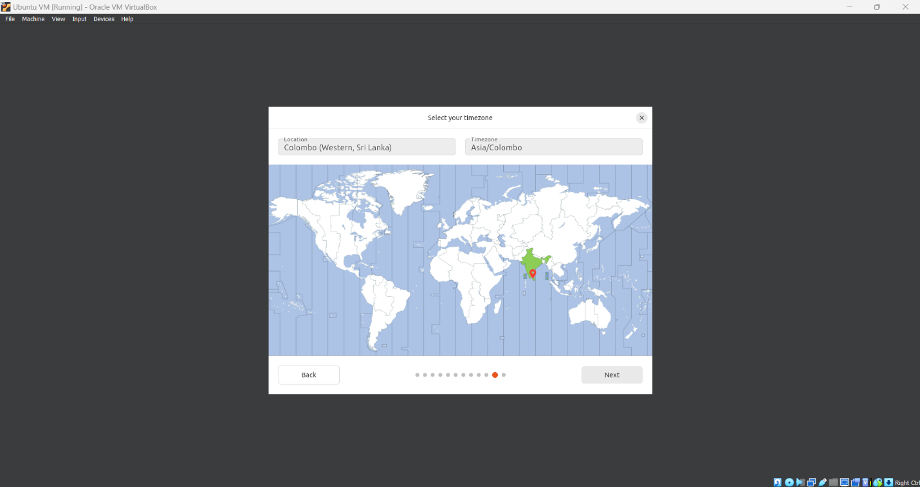

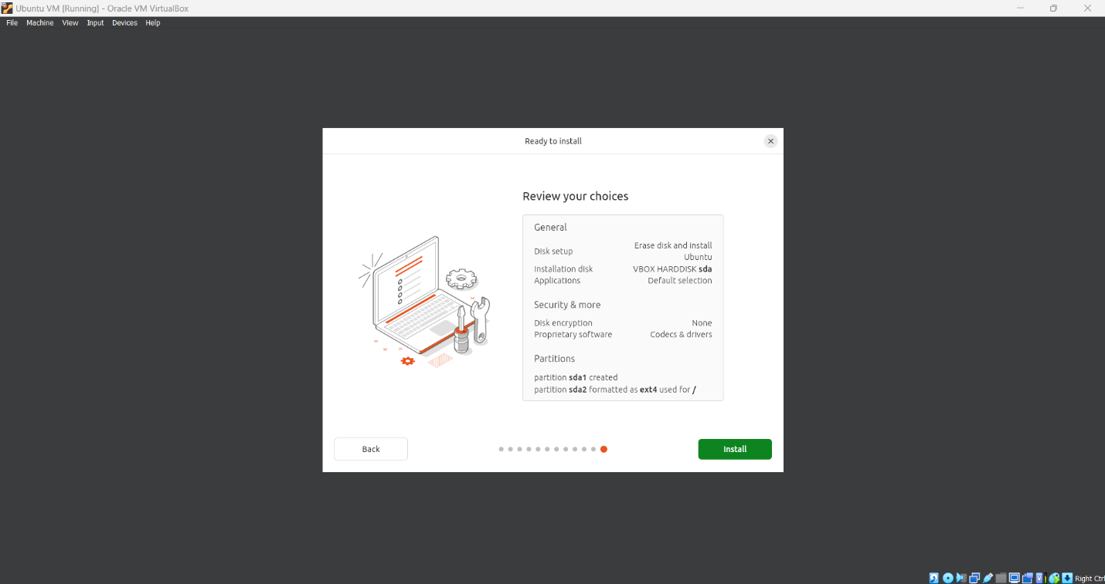

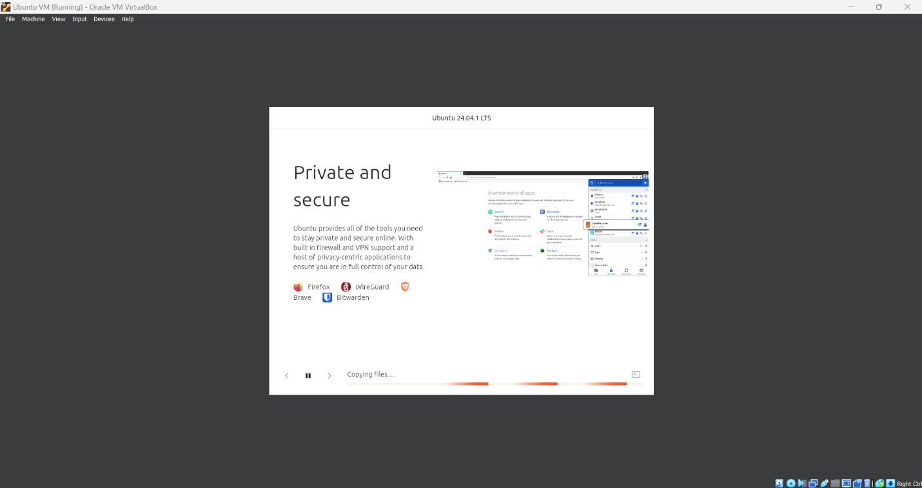

Once the installation is completed restart the virtual machine.

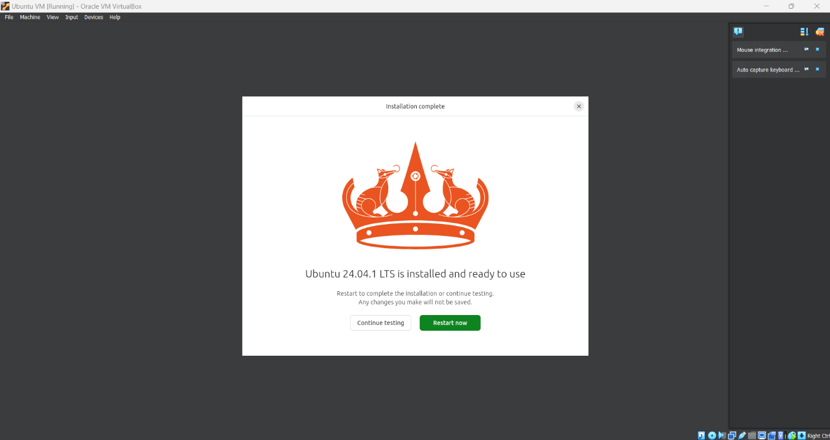

## Basic Navigation Commands and functionalities.

|  |  |
| --- | --- |
| **Command** | **Functionality** |
| ls | Listing items in the directory |
| cd | Change directory |
| pwd | Display the present working directory |
| mkdir | Create a directory |
| rmdir | Remove a directory |

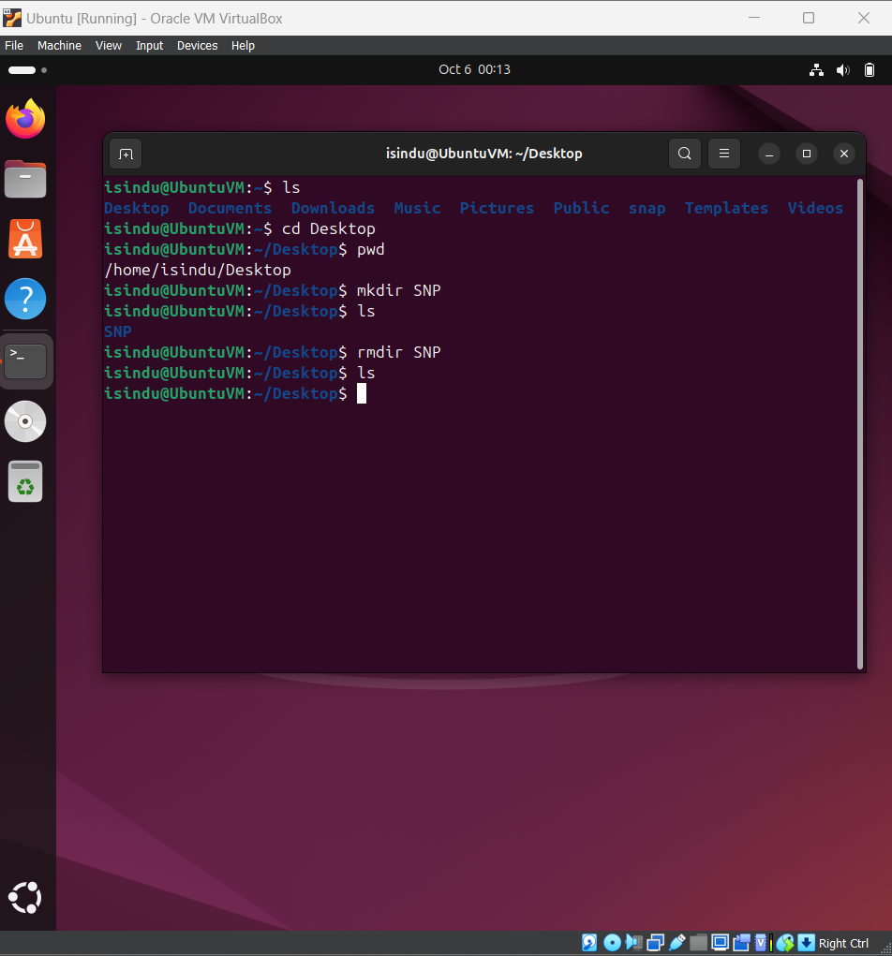

## File manipulation commands

|  |  |
| --- | --- |
| **Command** | **Functionality** |
| Touch | Creates a empty file |
| Nano | A text editor |
| Vim | A text editor |
| Cat | Displays file content |
| Chmod | Changes permissions of files / directories |
| Cp | Copy files / directories |

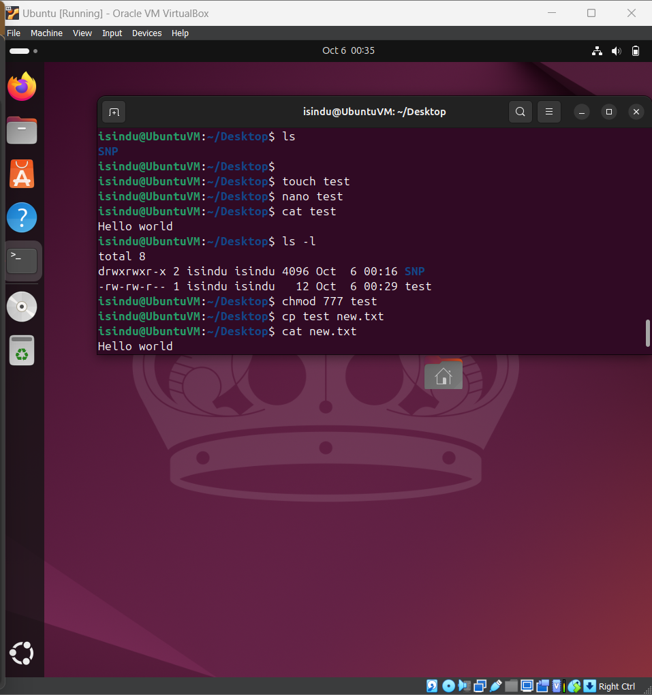

## System Information Commands

|  |  |
| --- | --- |
| **Command** | **Functionality** |
| uname -a | Provide detailed information of the system |
| df -h | Displays the information about disk space usage in human readable format such as MB, GB. |
| free -m | Displays the information about system’s memory usage in MB |

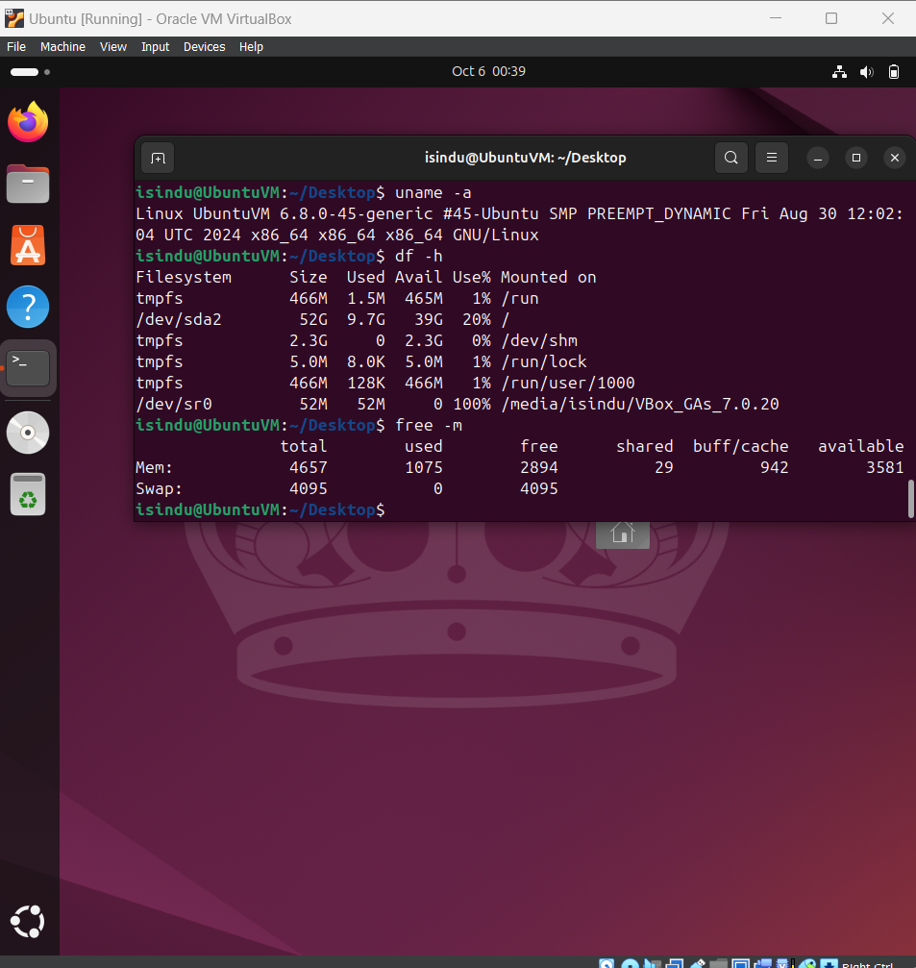

## User management commands.

|  |  |
| --- | --- |
| **Command** | **Functionality** |
| id | Displays the user information and groups information of the user |
| whoami | Displays the username of the current user |
| passwd | Change the password of the user |
| useradd | Add a new user in to the system |

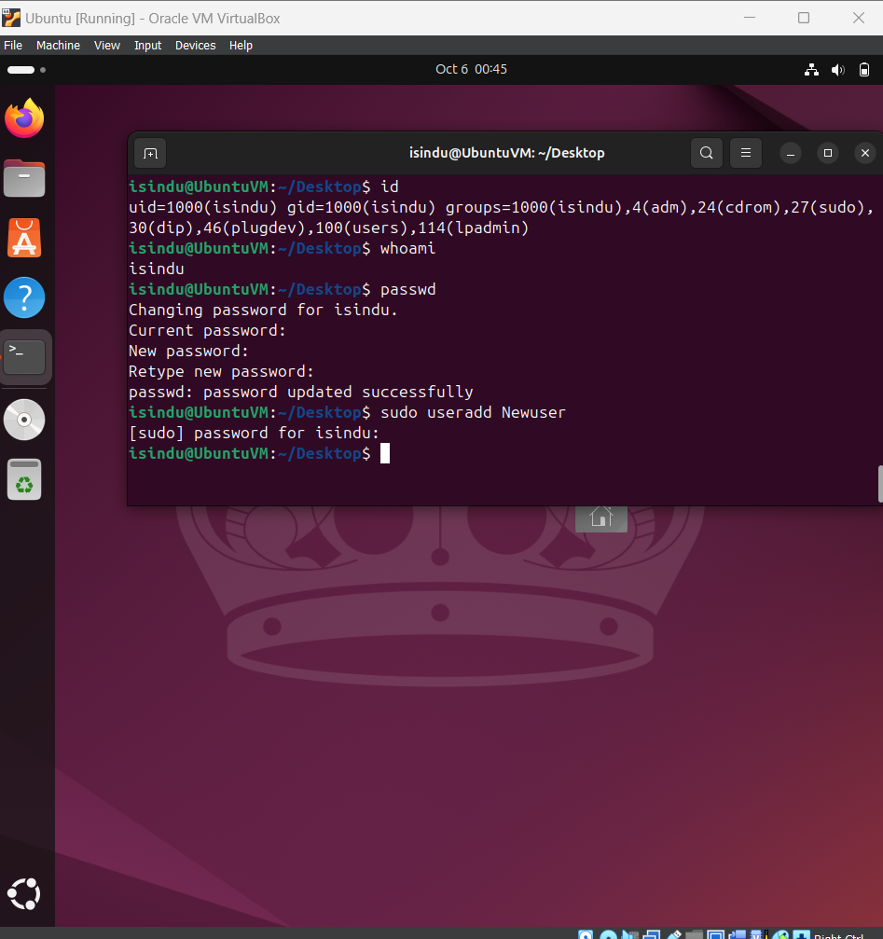

# **DHCP, DNS and NTP Services**

## DHCP (Dynamic Host Configuration Protocol)

DHCP (Dynamic Host Configuration Protocol) is a protocol used to automatically assign IP addresses to devices on a network.

## Installation and configuration

Open Terminal and install DHCP server package with “sudo apt install isc-dhcp-server” command.

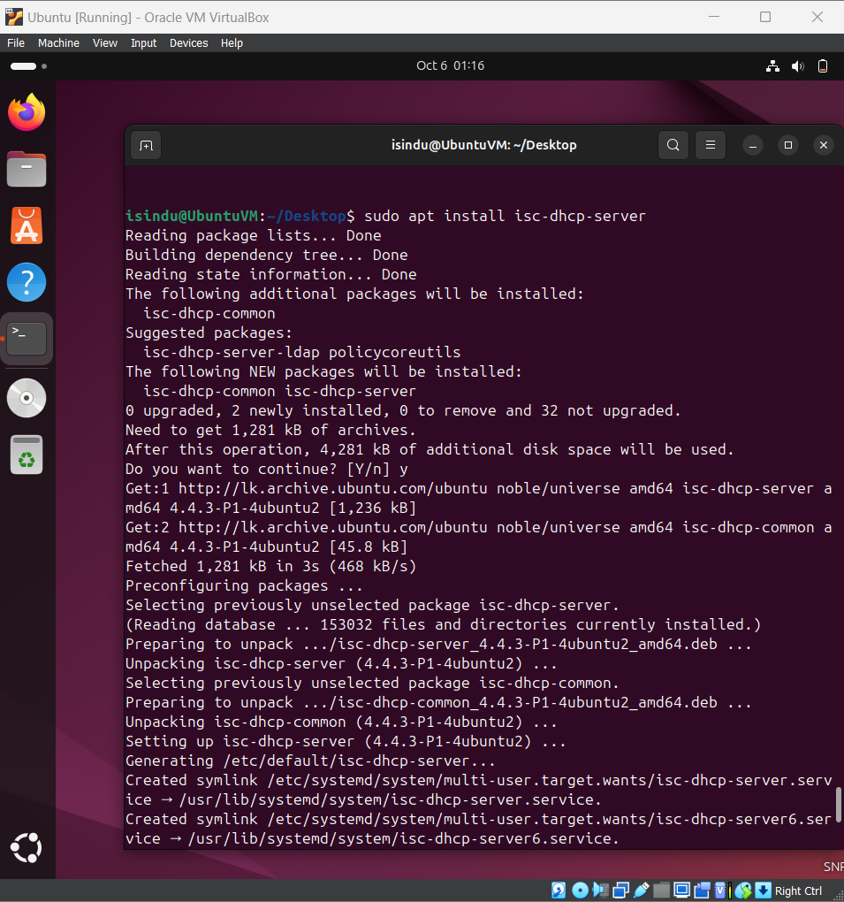

Use “sudo nano /etc/dhcp/dhcpd.conf ” to open and edit DHCP configuration file and modify it do define the network settings for the DHCP server and save it.

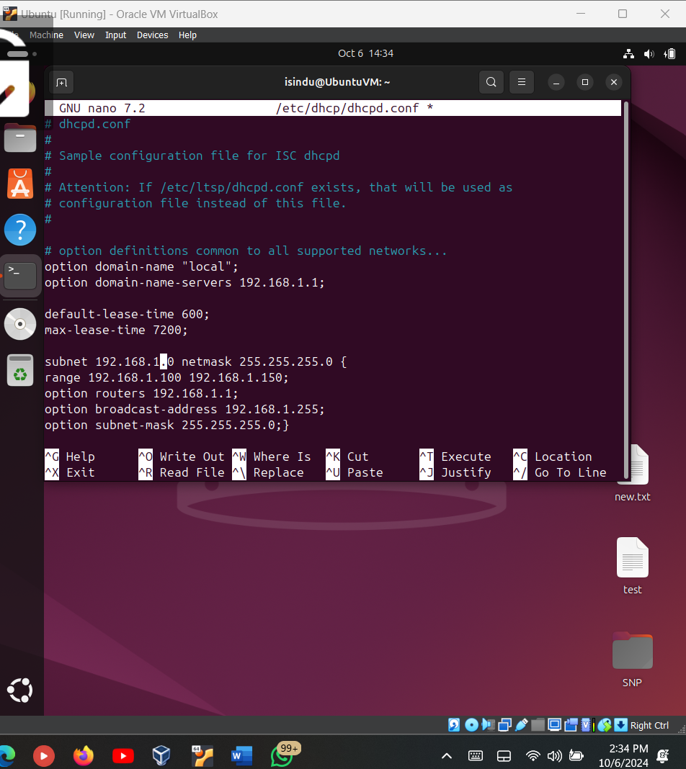

Use “sudo nano /etc/default/isc-dhcp-server” command to open and edit the DHCP server default file. Use “ip a” command to check network interface and make changes to the relevant interface.

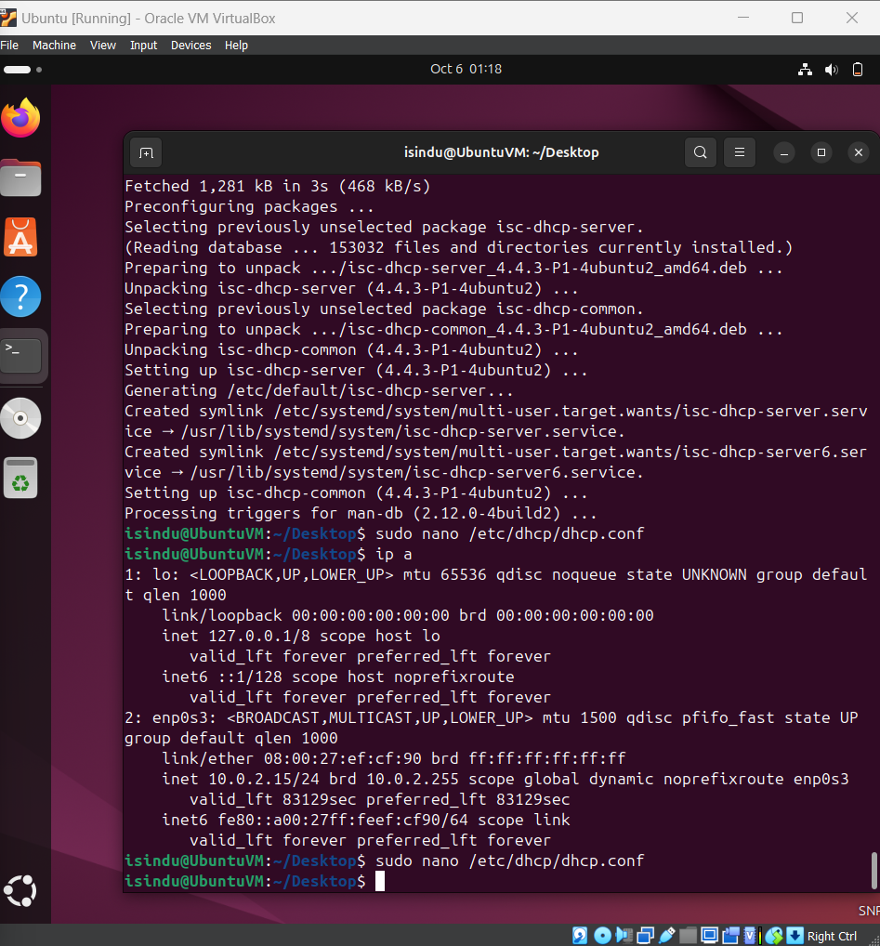

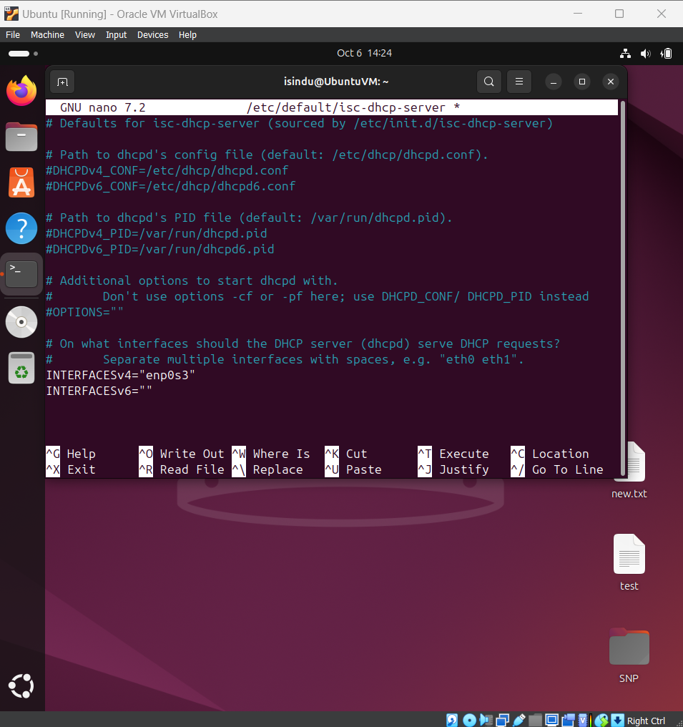

Start the service with the command “sudo systemctl start isc-dhcp-server”. We can enable it to run on boot with the command “sudo sytemctl enable isc-dhcp-server”.

Then check the status of the service using “sudo systemctl status isc-dhcp-server. If it displays no errors and if its running, we can verify by connecting another device (with DHCP on) to the same network and check if it has a IP address within the range we designed.

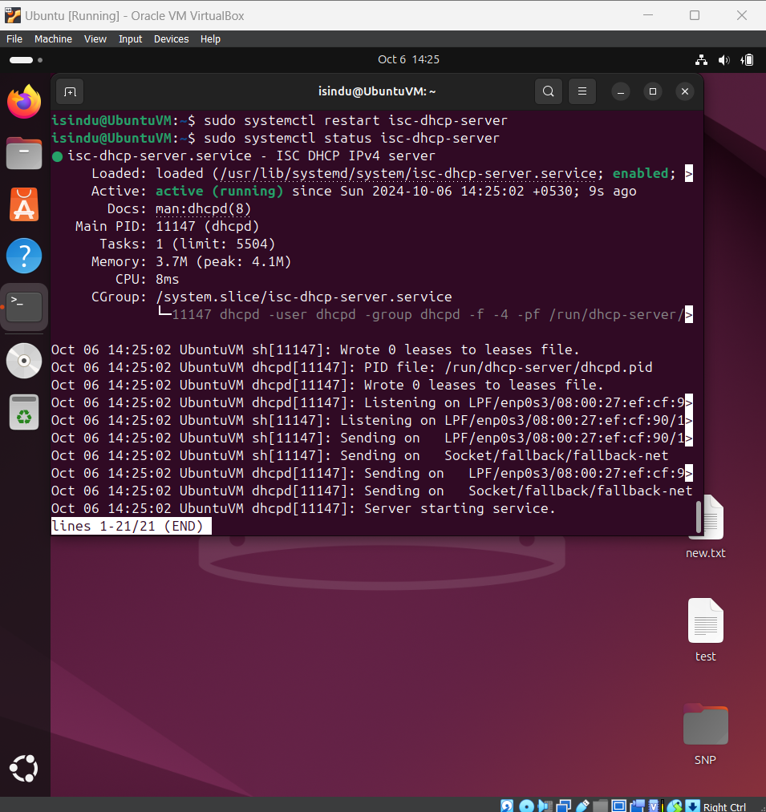

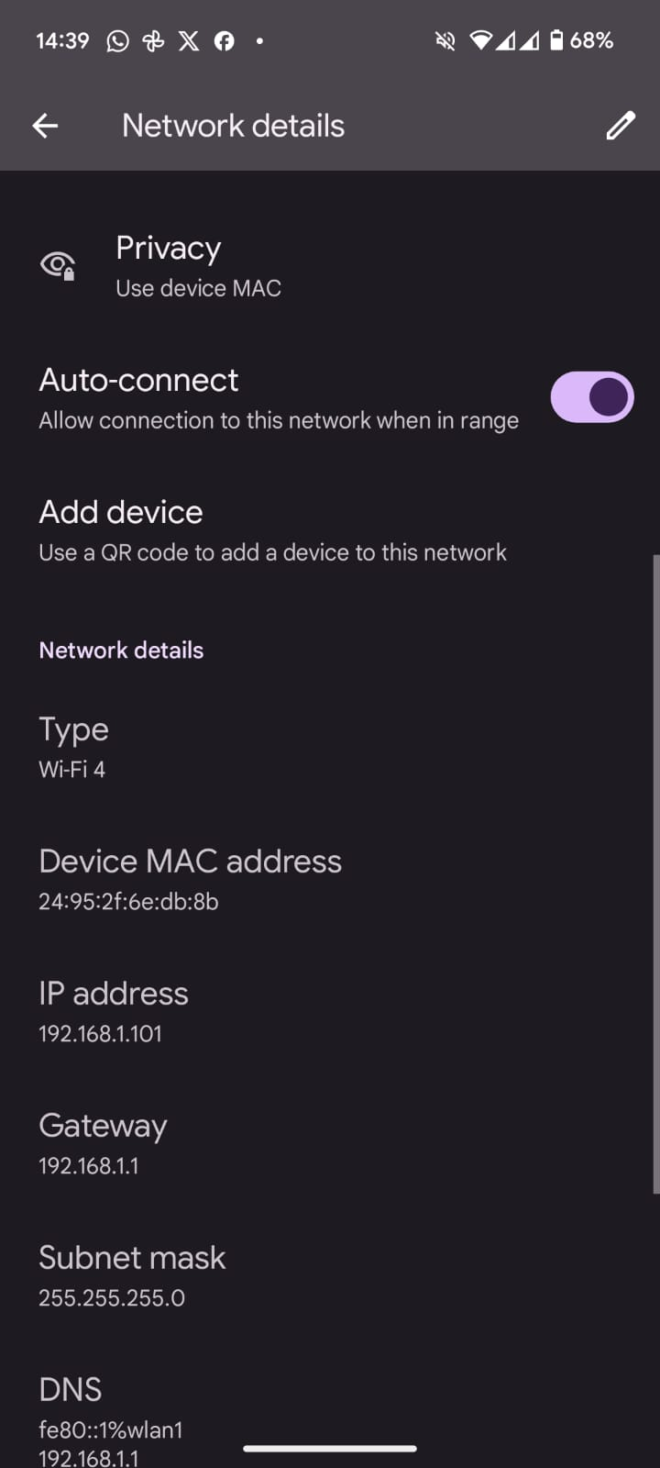

## DNS (Domain Name System)

DNS (Domain Name System) plays a crucial role in translating human domains names to machine readable IP addresses which allows users to access websites with ease.

## Installation and Configuration

Install a DNS Server like BIND (Berkeley Internet Name Domain) and packages with “sudo apt install bind9 bind9utils bind9-doc” command.

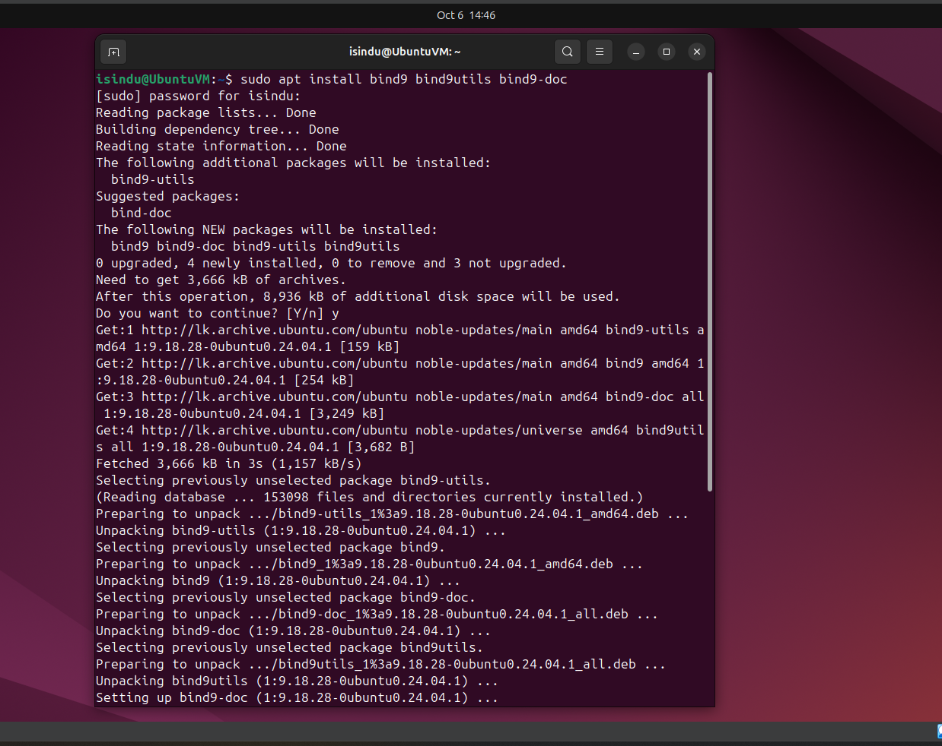

Open and edit BIND configuration file, zone configuration and copy the default zone file and edit copied zone file as well.

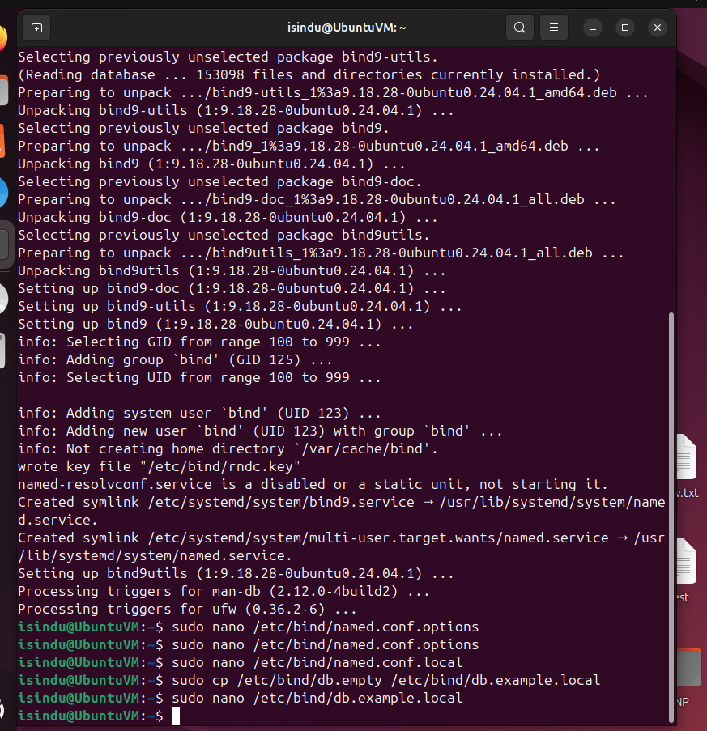

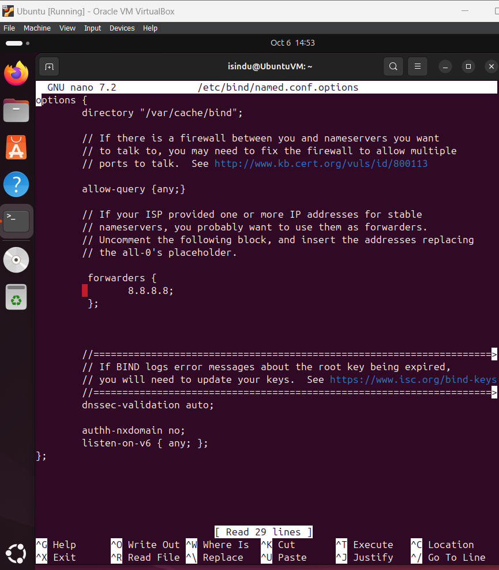

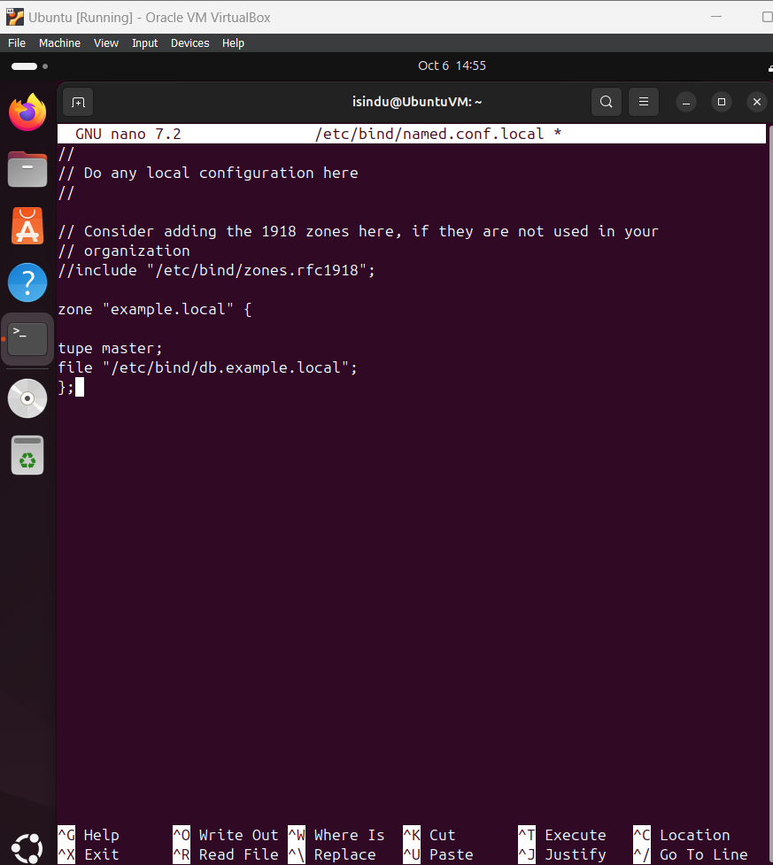

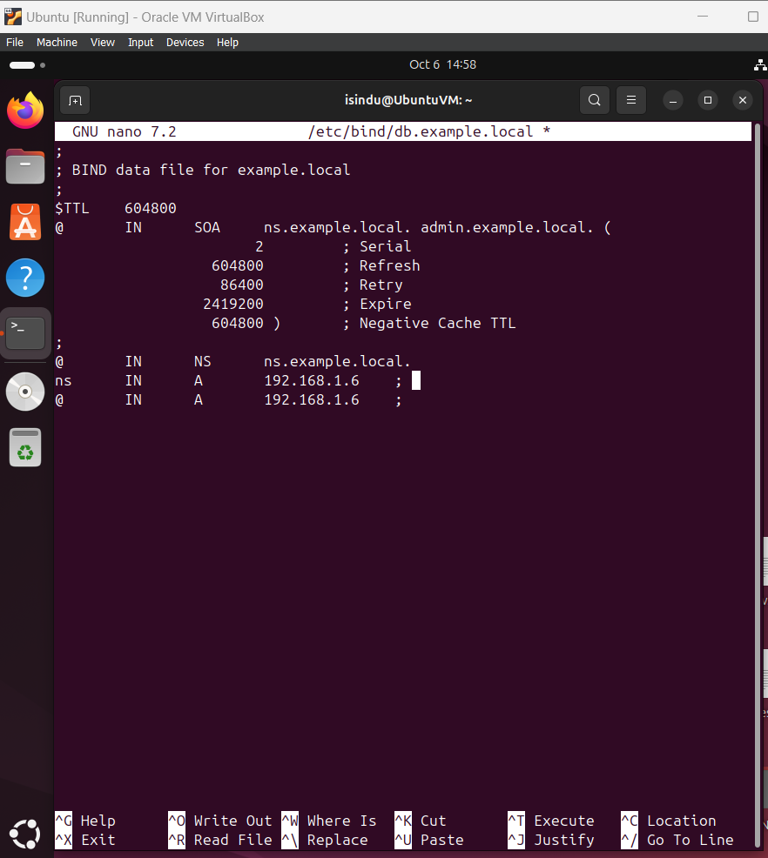

Check Bind configuration for errors with “sudo named-checkconf”. Then Restart the BIND and test the DNS server with “sudo systemctl restart bind9” and “dig” commands.

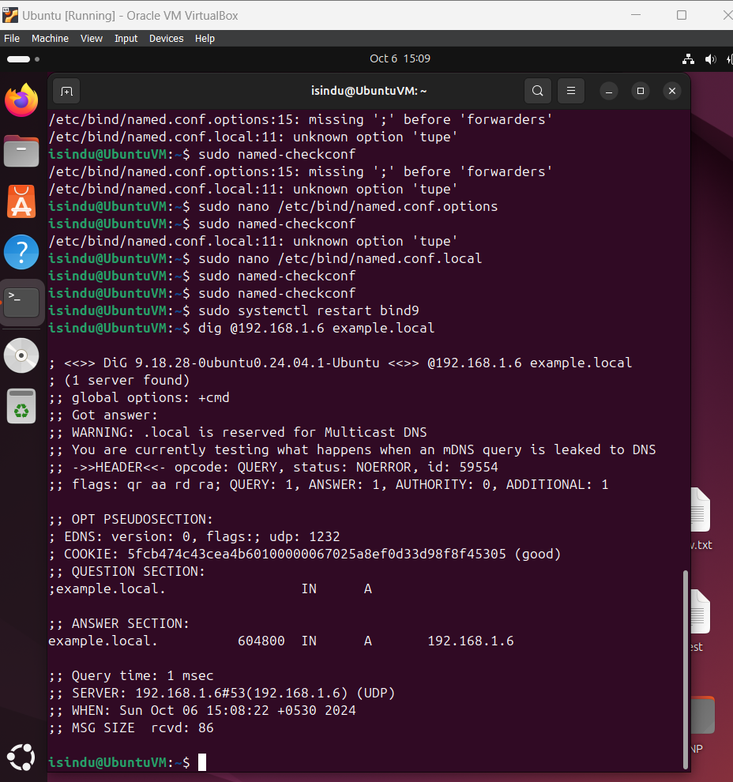

## NTP (Network Time Protocol)

NTP (Network Time Protocol) is a protocol designed to synchronize the clocks of computers in a network. IT ensures that all the computers on the network maintain the accurate time.

## Installation and Configuration

Install the ntpsec package “sudo apt-get ins ntpsec” then verify the ins with “sudo systemctl status ntpsec”.

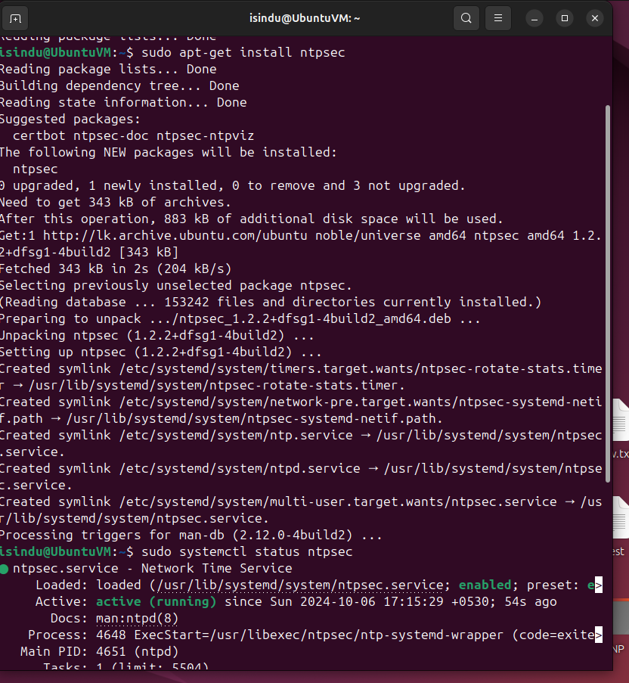

Open and edit the configuration file “sudo nano /etc/ntpsec/ntp.conf”

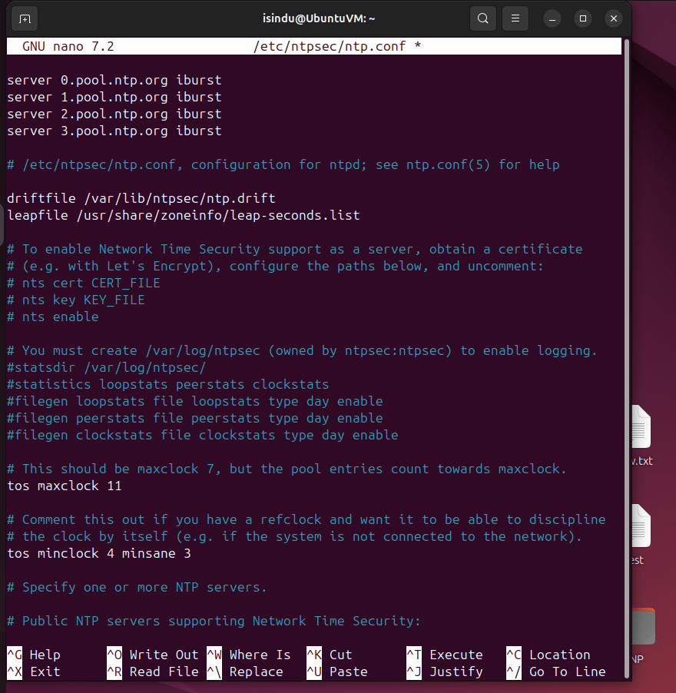

Use “sudo systemctl start ntpsec” to start the service and “sudo systemctl enable ntpsec” to enable service start at boot. Check whether the service is running without any errors with “ sudo systemctl status ntpsec” and check if the NTP service is synchronizing with servers using “ntpq -p” command.



# **Shell Scripting and Security**

## Shell Scripting

* + 1. Script to automate a report that captures system details every day.

Create a script file named system_report.sh and edit it using nano.

“nano system_report.sh”

Then Write the following script

REPORT_DIR="/home/isindu/system_reports"

#Defining the report file with the date

REPORT_FILE="$REPORT_DIR/system_report_$(date +%Y-%m-%d).txt"

# Check the REPORT DIR Exist and create if it doesn't

if [ ! -d "$REPORT_DIR" ]; then

mkdir -p "$REPORT_DIR"

fi

# Collect system information and write them in the REPRT FIle

echo "Date: $(date)" > $REPORT_FILE

echo "Uptime: $(uptime)" >> $REPORT_FILE

echo "Free Memory: $(free -m)" >> $REPORT_FILE

echo "Disk Usage: $(df -h)" >> $REPORT_FILE

# Print success message

echo "System report generated at $REPORT_FILE"

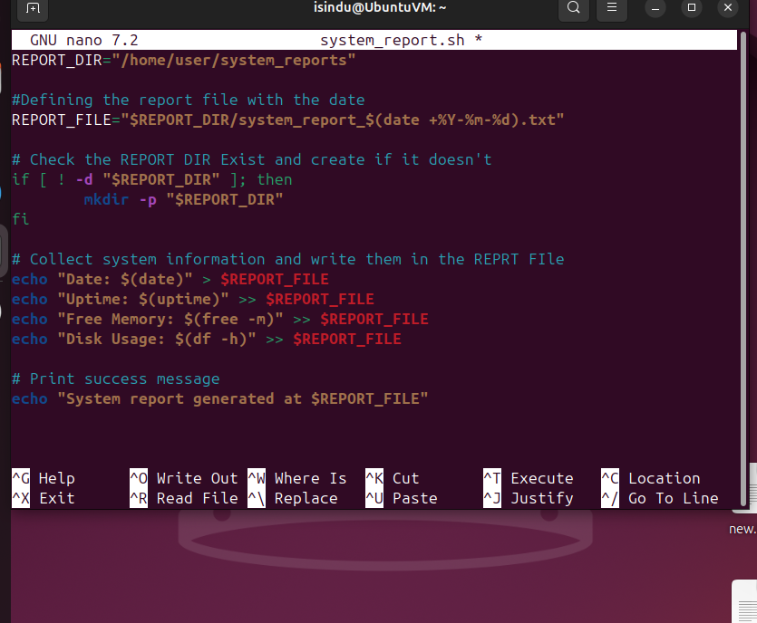

Make the script executable with “chmod +x system_report.sh”

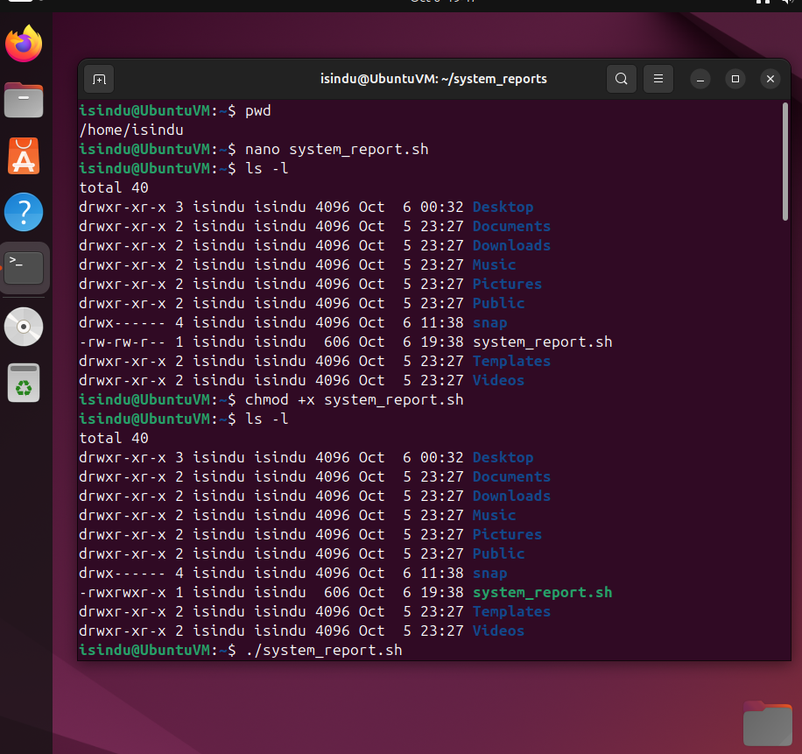

Test the script by running it manually. “./system_report.sh”

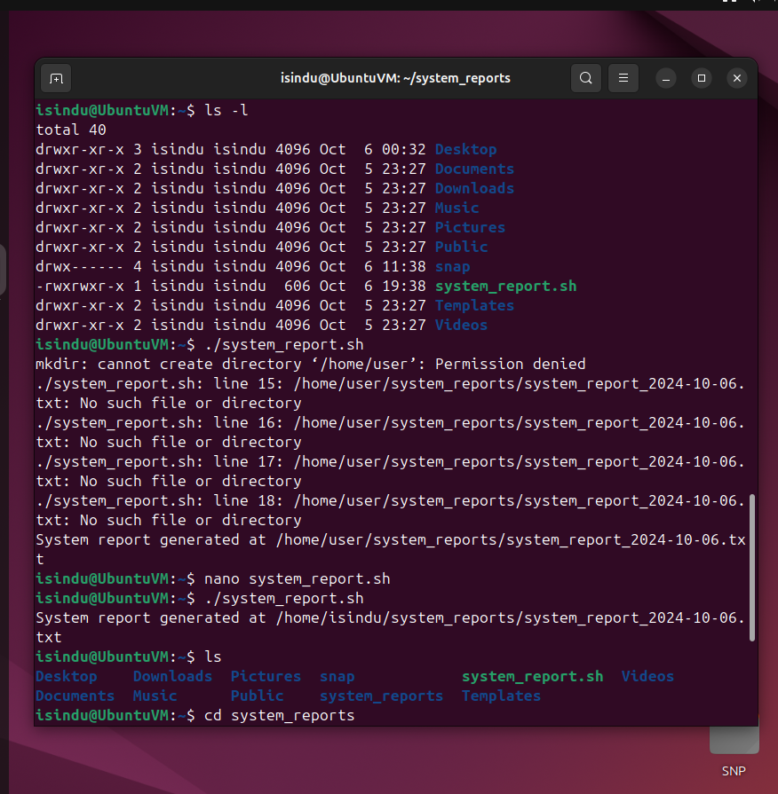

Read and check the contents of the file with “cat /system_reports/ system_report_2024-10-06.txt”

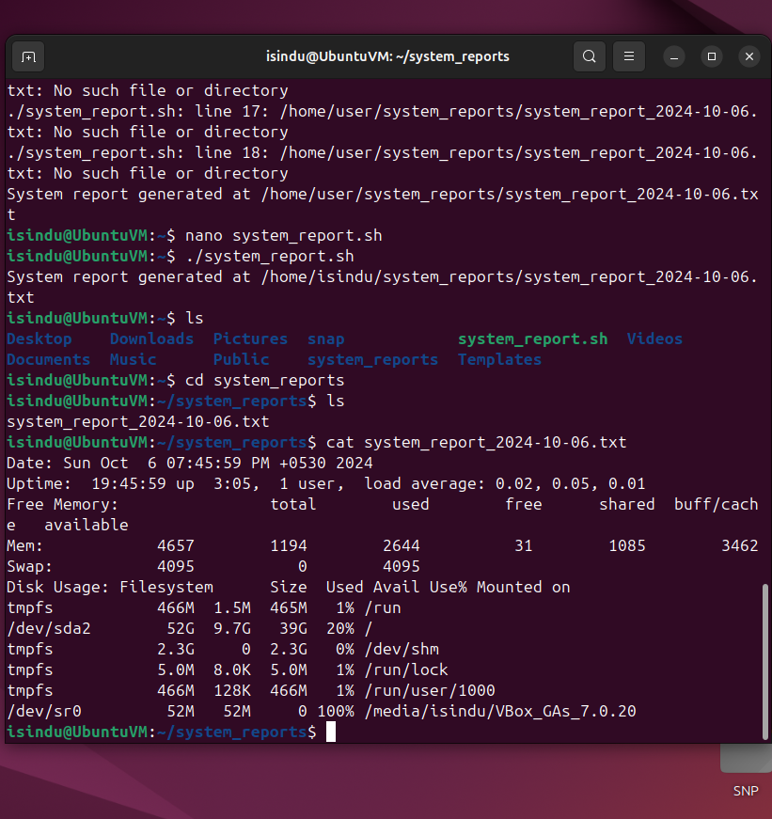

This report contains current date, system uptime, number of users, Memory details, disk usage etc.

To automate the script open the crontab file. “crontab -e” and select a editor. Following command tells cron to run the script at 8.00 AM everyday.

0 8 * * * /home/isindy/system_report.sh

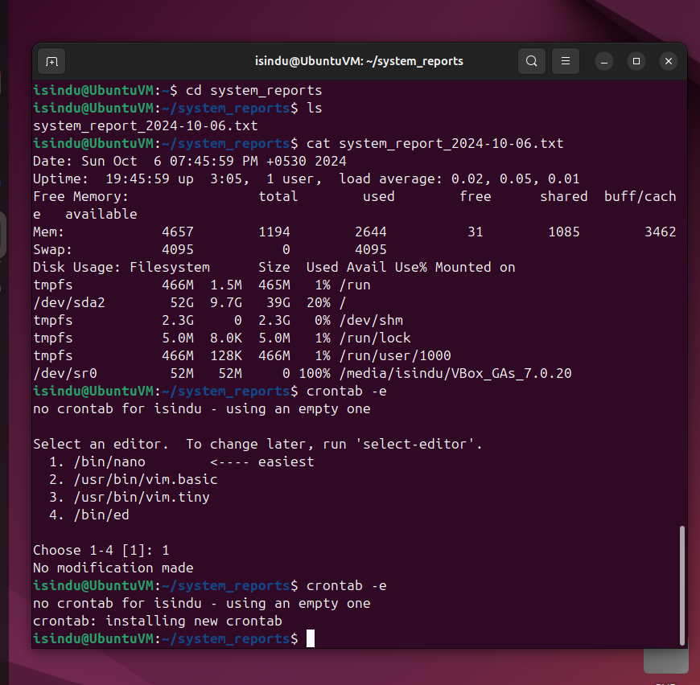

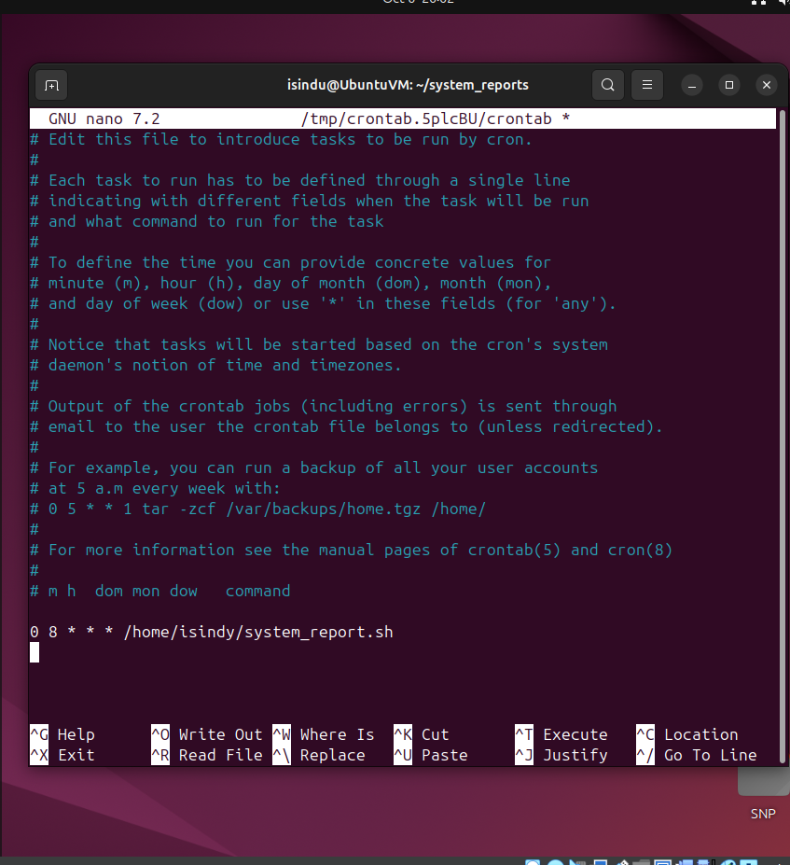

* + 1. Script to automate the backup of the Documents directory

Create and edit a script file named backup_script.sh using nano.

“nano backup_script.sh”

Insert the following script and save the file.

#!/bin/bash

# Define source and backup directories and backup file name with date

SOURCE_DIR="/home/isindu/Documents"

BACKUP_DIR="/home/isindu/backup/Documents"

BACKUP_FILE="$BACKUP_DIR/backup_$(date +%Y-%m-%d).tar.gz"

# Create Backip dir if it doesn't exist

mkdir -p $BACKUP_DIR

# Create the backup

tar -czf $BACKUP_FILE $SOURCE_DIR

# Print success message

echo "Backup created at $BACKUP_FILE"

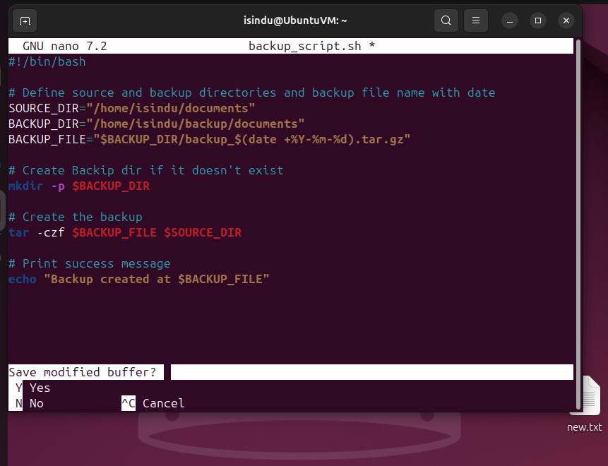

Make the script executable.

“Chmod +x backup_script.sh”

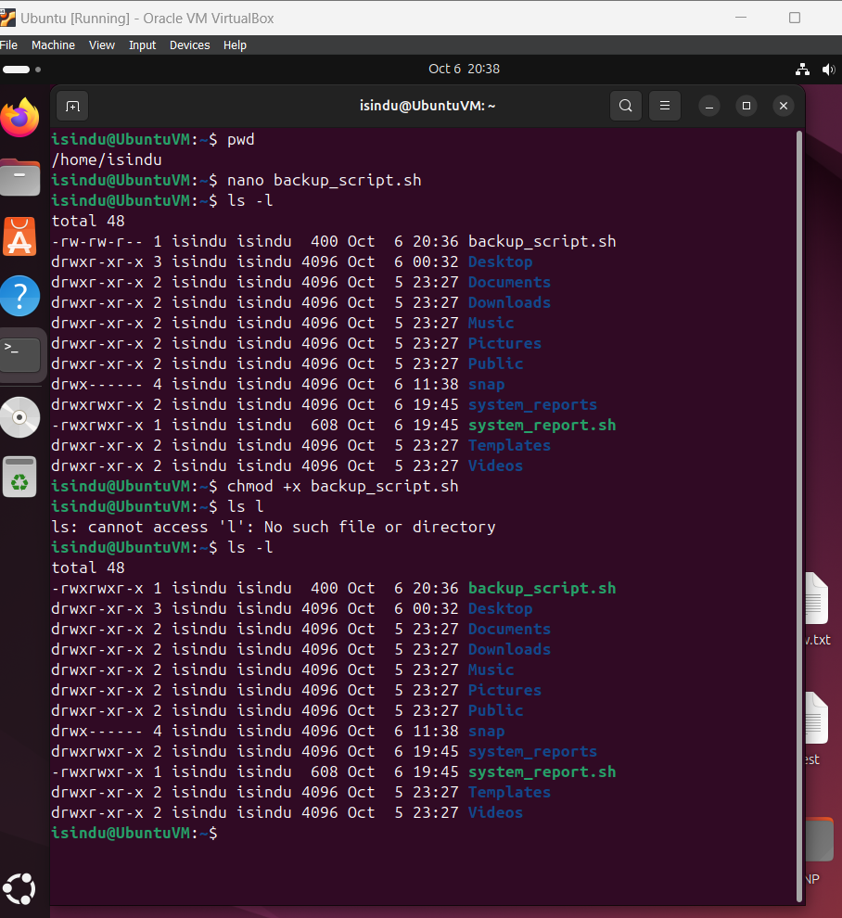

Run the script manually to check whether its work.

“backup_script.sh”

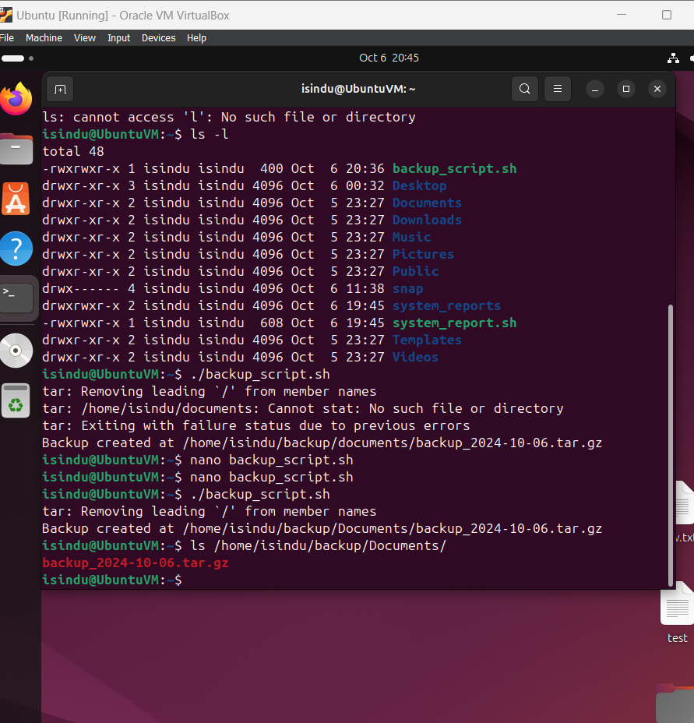

If you got the successful message check the Documents directory for the backup file.

To automate the backup script, open Crontab file.

“Crontab -e”

Edit and add Cron job to run the script periodically.

0 6 * * * /home/isindu/backup_script.sh

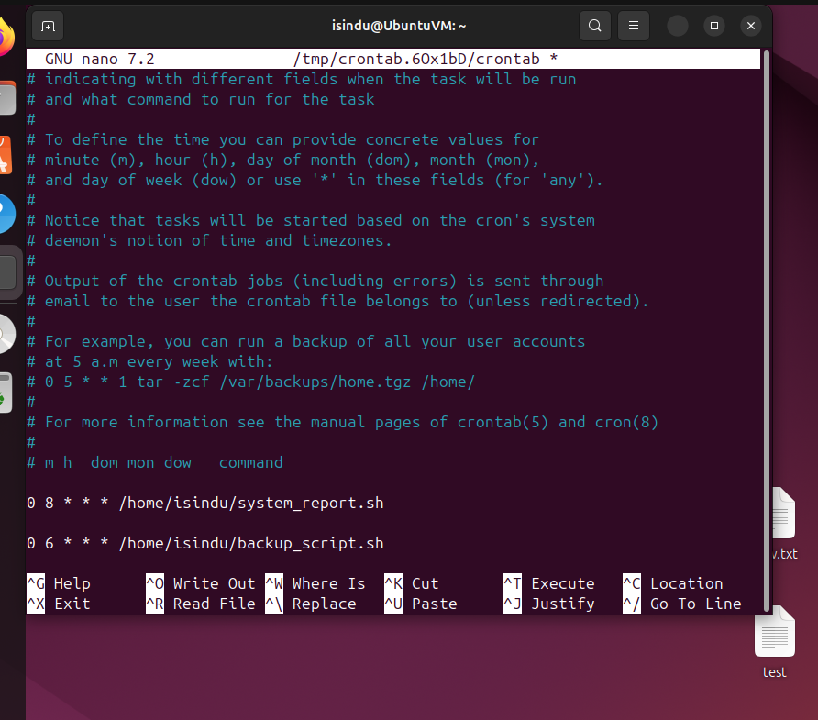

This tells Cron to run the script every day at 6.00 am

## SSH (Secure Shell)

Install the ssh server.

“sudo apt install openssh-server”

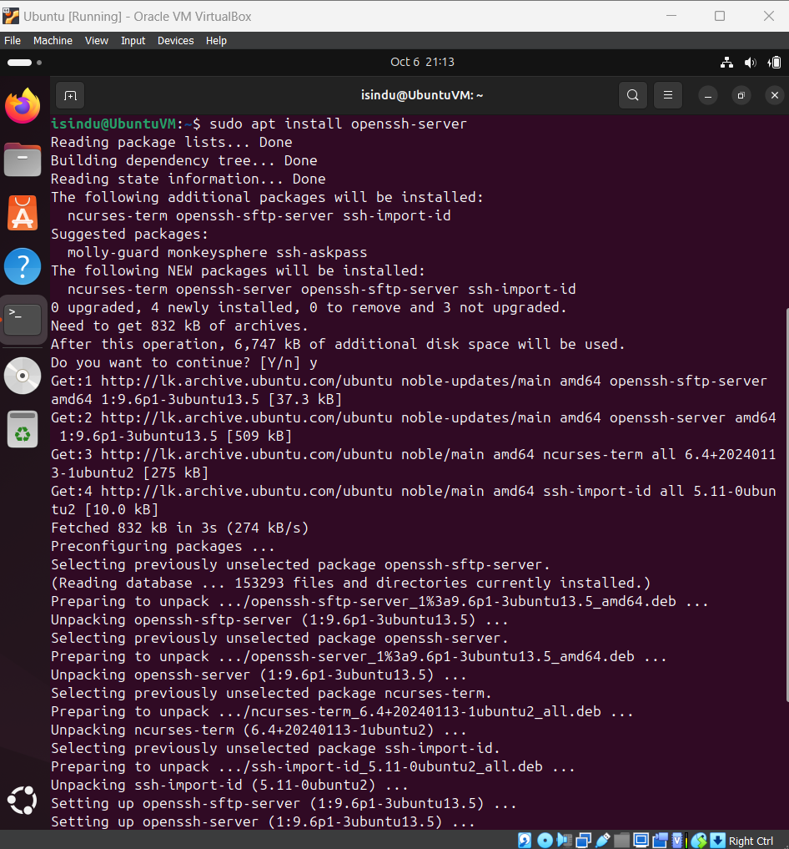

After installation start the SSH service with following command.

“suto systemctl start ssh”

Make the service auto start at boot.

“sudo systemctl enable ssh”

Check the status of the system.

“sudo systemctl status ssh”

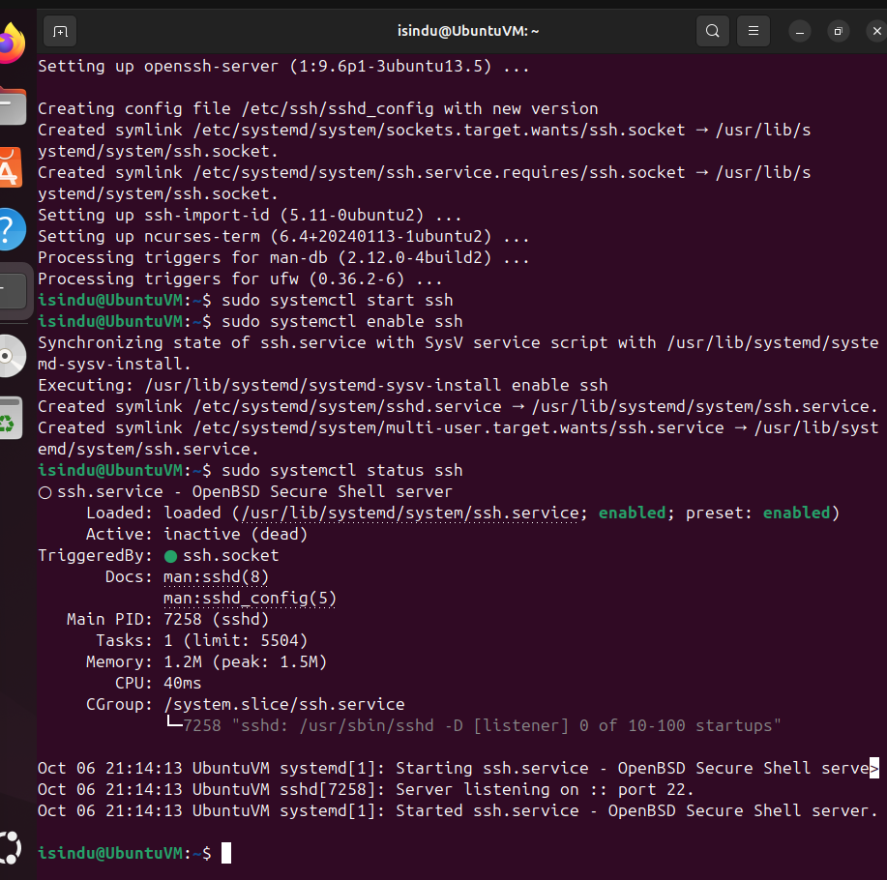

Find the ip address of the virtual machine.

“ip a”

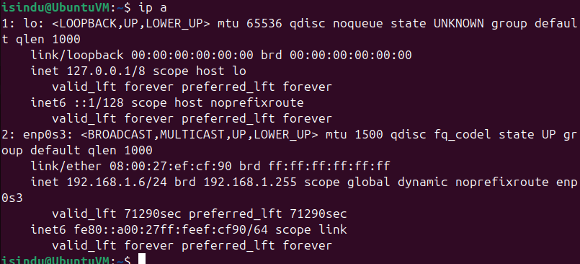

Then use the client computer’s terminal and enter “ssh [isindu@192.168.1.6](mailto:isindu@192.168.1.6)” to connect to the virtual machine.

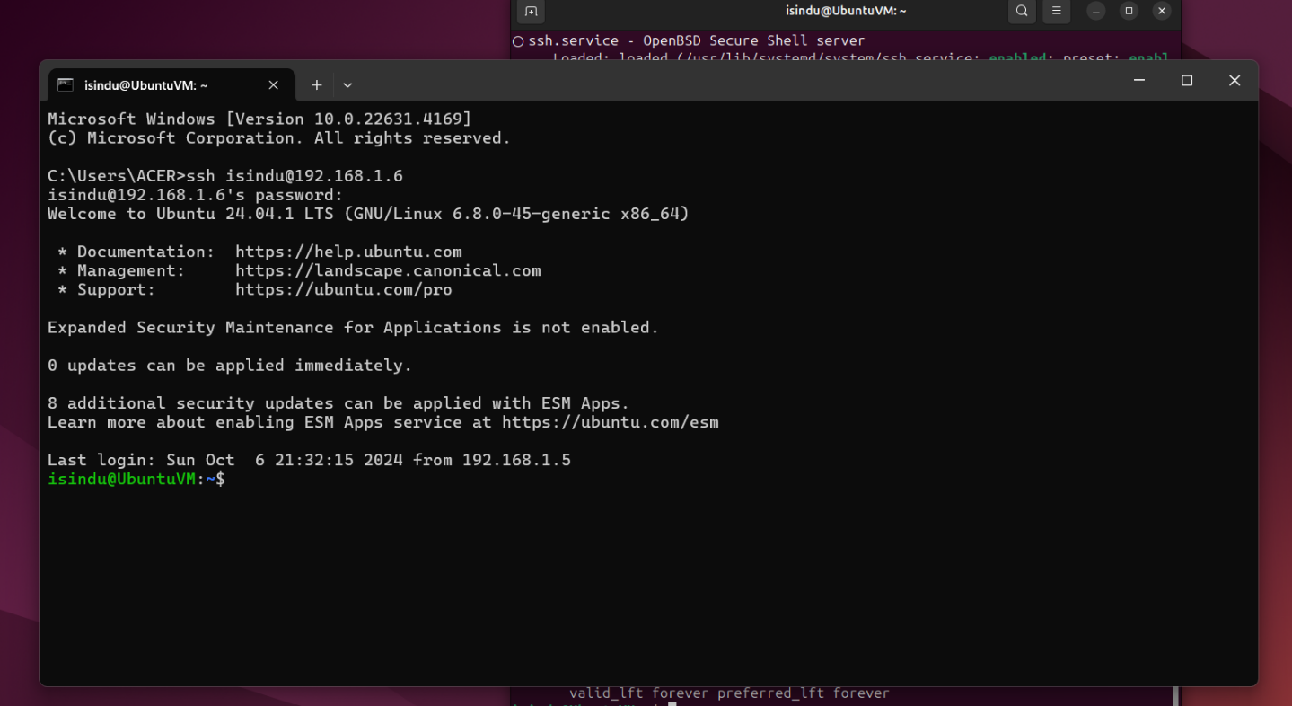

## Iptables and ACLs

* + 1. Web Sever Security

Install iptables

“Sudo apt install iptables”

Set default policies

“sudo iptables -P INPUT DROP”

“sudo iptables -P FORWARD DROP”

“sudo iptables -P OUTPUT ACCEPT”

Allow incoming traffic on port 80 (HTTP)

“sudo iptables -A INPUT -p tcp --dport 80 -j ACCEPT”

Allow incoming traffic onn port 443 (HTTP)

“sudo iptables -A INPUT -p tcp --dport 443 -j ACCEPT”

Allow established and related connections

“sudo iptables -A INPUT -m conntrack --ctstate ESTABLISHED,RELATED -j ACCEPT”

Save set rules.

“sudo iptables-save | sudo tee /etc/iptables/rules.v4”

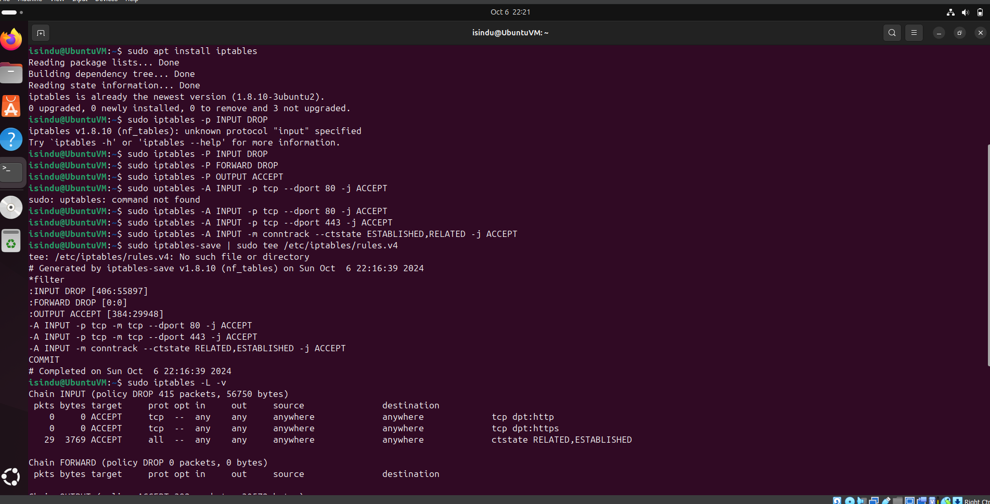

* + 1. Remote Administration Access

Use the following command to ALLOW SSH access (port 22) only from 192.168.1.5 used for administration.

“sudo iptables -A INPUT -p tcp -s 192.168.1.5 --dport 22 -j ACCEPT”

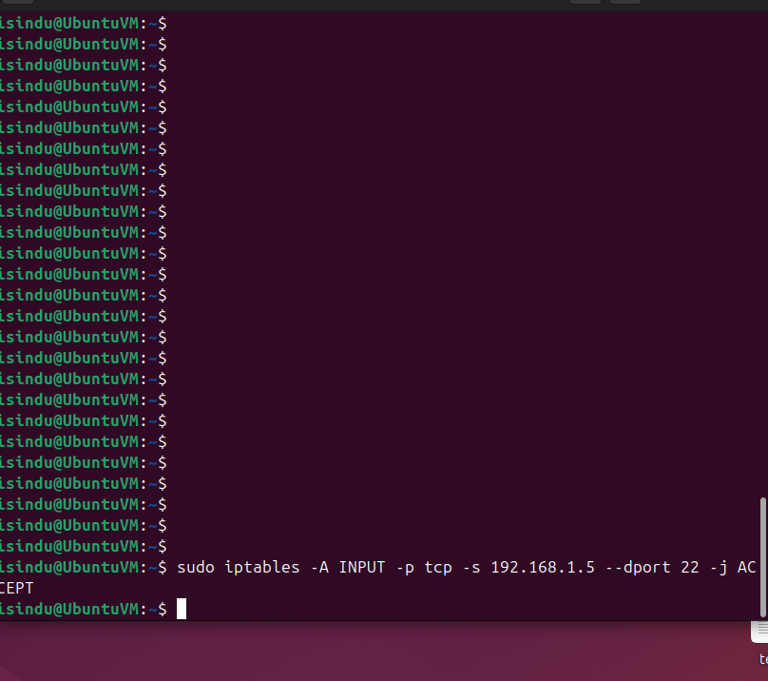

* + 1. Allow Specific Application

Use the following command to allow specific application.

“sudo iptables -A INPUT -p tcp --dport 443 -j ACCEPT”

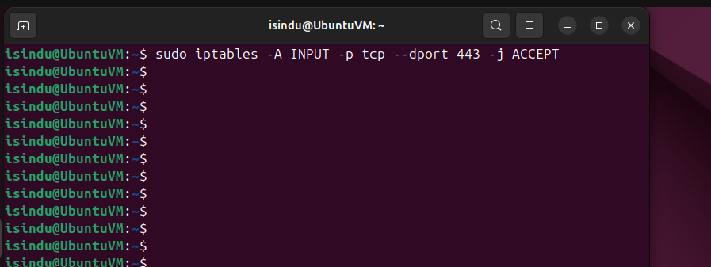

* + 1. Allow Pings (ICMP Echo Reques)

Use the following commands to allow ping request (ICMP Echo Request)

“sudo iptables -A INPUT -p icmp --icmp-type echo-request -j ACCEPT”

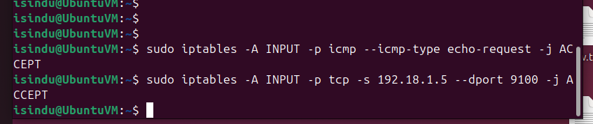

* + 1. Printer Server Access

Use the following command to allow printing traffic only from 192.168.1.5

“sudo iptables -A INPUT -p tcp -s 192.18.1.5 --dport 9100 -j ACCEPT”



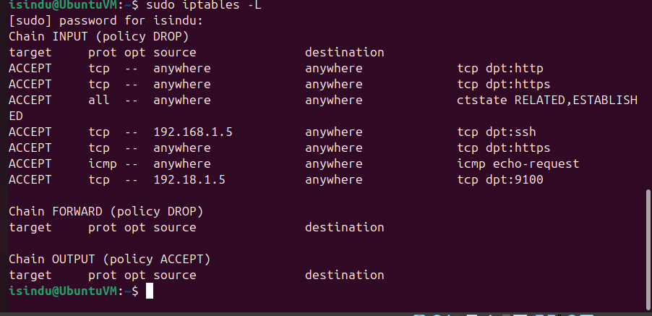

# Best Practices

1. Disable Unnecessary Network Interfaces

Some of the interfaces that comes with the system may not be required. Leaving unused interfaces active can expose the system to unnecessary risk.

“ip link show” command lists out the interfaces in the system.

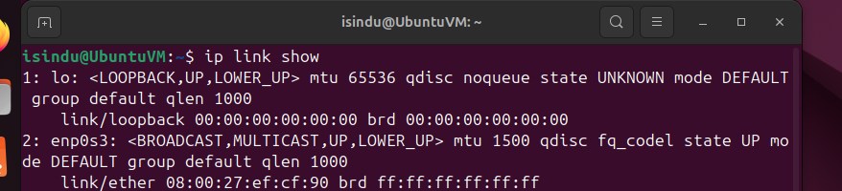

Use “sudo ip link set [interface] down” to disable unnecessary interfaces. ( I do not have any unnecessary interfaces)

1. Enable and configure firewall

Configured firewall controls the flow of traffic to the system and from the system which will help to prevent the system.

To install and enable firewall use

“apt install ufw” and “ufw enable” commands

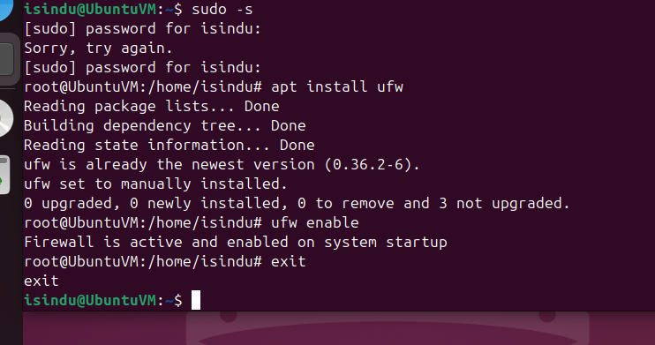

You can configure firewall using iptables rules.

1. Disable IP Forwarding

IP forwarding is the process of forwarding packets between different network interfaces. It is unnecessary to the server configuration unless the machine is acting as a router.

You can check the status of IP fording.

“sysctl net.ipv4.ip_forward”

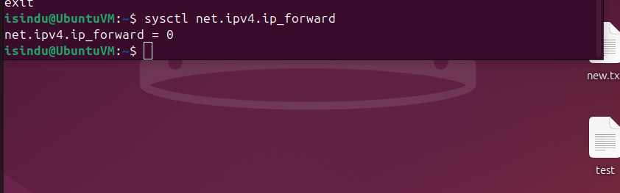

If IP forwarding is on disable it by editing syctl configuration file and modifying net.ipv4.ip_forward = 0

1. Configure NTP Securely

Exposing NTP services without securing them can allow at manipulate time or use the system in a DDoS amplification attack.

1. Use Secure DNS Configurations

DNS configurations can be exploited to redirect traffic or eavesdrop on communication. Secure DNS setups prevent DNS spoofing, cache poisoning, and other DNS-related attacks.